


Unofficial Manual

www.hedgewars.org

Author:
rbaleksandar

Copyright (C) 2009 rbaleksandar.
Permission is granted to copy, distribute and/or modify this document
under the terms of the GNU Free Documentation License, Version 1.3
or any later version published by the Free Software Foundation;
with no Invariant Sections, no Front-Cover Texts, and no Back-Cover Texts.
A copy of the license is included in the section entitled "GNU
Free Documentation License".

Thanks to all who dedicated their time to making this game, all the useful information on the official web site of Hedgewars and its great community. Parts of this manual are taken from Hedgewars' Wiki and/or from the forum. I'll try to mention the author(s) but sometimes I won't be able to due to the fact that I don't know who wrote them.

This manual might not be for the latest release of Hedgewars
Please visit the official site to see if there isn't an updated version
of this manual, which covers all new features in the latest release.
This manual is for release 0.9.11.

This page was initially left blank.
(don't know why...yet :))
Contents

- About Hedgewars, the main goal, the community and a couple of angry hedghogs
- Downloading the game and installing it
- Starting the game for the first time. Configuration
- Main menu
- Options menu
- Game modes. Setting up a game
- Local
- Network
- Interface, controls, weapons and tactics or how to achieve eternal glory
- Interface
- Game controls and basic movements
- Weapons description and usage guidelines
- Advanced tactics
- Internet gaming
- First match and all that follow
- Etiquette
- Demos
- FAQ, troubleshooting and support
- Hedgewars Tournament and online ladder
- Contributing to the game
- Creating game contents – ideas, hats, maps, themes and more
- Development - http://cia.vc/stats/project/hedgewars
- Funds
- Appendix A – Map types
- Appendix B – Implemented game schemes
- Appendix C – Default key binds (clip-art)
- Appendix D – Chat commands
- Index
- Credits
- GNU Free Documentation License



1

About Hedgewars, the main goal, the community
and a couple of angry hedgehogs

Attention, cadet! You're in the army now.
Let's start with how it all started. Some of you might have heard of the cult game series Worms (starting with the old DOS version Worms 1 with 2D graphics and ending up in the third dimension). Well, as you might have already guessed, there's no point in mentioning this game unless Hedgewars (for short - HW) has nothing to do with it. Both games are artillery turn-based strategical games. Both have many many things in common but also many things that make them different from one another. Maybe due to the fact that HW is a free open source game, it's contents are being modified all the time and pretty often. Most of the time new features are added and/or are brought to perfection.

TEXT[history]

The main goal is not to recreate a total copy of Worms or any other similar game. HW takes the basic concepts, that are implemented in all other games of this type, and adds something more. As the author of the engine - Andrey Korotaev (known as unC0Rr) - said once: “If you want to play Worms, go and play Worms.” In plain and short text – HW isn't Worms.
As all successful open source projects this game has a great community which grows with the hour. You can always find something new, interesting and/or helpful there. The forums (and the IRC channel) are mainly used to discuss game features, improvements etc. More about contributing to the game in chapter 10.

Main HW-sources on the internet:
- Official site (downloads, forum, HW-wiki, chat)
- Hedgewars' Wiki (more detailed information on some aspects of the game)
- Wiki (short description plus detailed list of all versions up to the nightly release)
- Facebook (developer's diary, discussions)
- YouTube (videos with HW by fans and developers)
- Twitter (latest news about the development of the game)
- Manual's thread (tell me how awesome I am, suggestions, corrections)
- Forum (discussions)
- Language specific discussions (discussions in French, German, Italian, Polish and Russian)
- News

What to expect from this *cough* awesome *cough* manual?

Here you will read how to play (at least the basics including some pro-tips and tricks), how to create great servers, how to become a HW-art-master and much much more. I'll try to explain everything in a straight forward way – all you need to know to enjoy this wonderful game. It includes guidelines, tutorials, dozens of tips etc. I hope you enjoy reading it and that it'll help you master the art of Hedgewars. :) If you have suggestions/corrections for this manual, please contact me in the forum. I know it's far from perfect. If you want, you can even translate this in your language so that more people over the world experience what you have while playing HW.
The Manual goes with two other files – weapons/utility table in ODS and XLS format.
Note: ODS documents can be opened with OpenOffice Spreadsheet. XLS documents can be opened with Microsoft's Excel 97-2007.

How to use this (again) *cough* awesome *cough* manual?

It's divided in chapters, which follow a curtain flow – from the first steps to the great action. In order to return to the Contents-page of this manual you can click on the small hedgehog that is on each title page of each and every chapter. It looks like this:
The appendixes present some additional information that you might find useful (but not necessary). There are a lot of images to show you how actually something looks so that you can “compare” what you have with what's in this manual. I have to warn you for the following things may be a problem:
- Mistakes – everyone makes 'em and I'm not an exception. I'm not talking about grammar, punctuation etc. (I'm sure they suck...hard). I'm talking about inaccuracies and even false information. I went through the whole thing many times but there still might be things to fix and/or change. If something looks weird for you and you think it might be a mistake – feel free to contact me (on the forum).
- Missing things – this might be due to the fact that there is a new version of the game and I still haven't edited the manual so that it can cover it. Before posting “You've missed something” look at the release summary and what has changed (look at the links on the previous page). If it's a new strategy you have or something to add I'll be glad to include it.

2

Downloading the game and installing it

Now that you already know how super-duper awesome this game is it's time to get it and install it in order to be able to play it (it's simple, dear Watson).

Download the game

On the page above you can find all available stable releases (installers and packages for different operating systems), source code (for compiling or development) and goodies. For nightly releases (that is the next yet unstable release which is still being modified) can be obtained on the IRC channel (also available as LiveChat-tab here):

Network: FreeNode
Main IRC Server: irc.freenode.net
Port: 6667
Channel: #hedgewars

Nightly releases aren't so widespread so you might consider using the stable release in order to avoid problems due to instability of the game and playing in multiplayer mode. But of course you can still install it in order to see some (if not all) of the new features and maybe help improving the next release.
Installing the game isn't difficult. Because of the very active community the chances you find an installer/package for you operating system are pretty decent. Along with that HW comes in many different languages.
Basically HW can be installed on any computer that has:
- Qt >= 4.4
- FreePascal >= 2.2.0
- SDL >= 1.2.5
- SDL_net >= 1.2.5
- SDL_mixer >= 1.2
- SDL_image >= 1.2
- SDL_ttf >= 2.0
- CMake >= 2.6.0

For Debian users:
- cmake
- qt4-qmake
- libqt4-dev
- libsdl1.2-dev
- libsdl-net1.2-dev
- libsdl-mixer1.2-dev
- libsdl-image1.2-dev
- libsdl-ttf2.0-dev
- fpc

If you're not familiar what is compiling and complicated things like that, better take an out-of-the-box package/installer or ask in the forum if someone can make a package for you. But if you're an enthusiast and want to compile the source code all by yourself, here's what you should do:

- Configure:
$ cmake
or
$ cmake -DCMAKE_CXX_FLAGS="flags" -DCMAKE_INSTALL_PREFIX="install prefix" -DDATA_INSTALL_DIR="data dir" -DWITH_SERVER=1
- Compile:
$ make
- Install:
# make install

Note: Compilation option WITH_SERVER=1 requires GHC
Additional links (download pages are provided below; instructions on how to use these tools can be found on the site of the specific product):
- Qt
- FreePascal
- Cmake
- GHC

Officially HW can be installed on Linux-, Windows- or FreeBSD systems (32 and 64bit x86 architecture). Ports can be made for other OSs.

Minimal system requirements (maybe even lower):

Intel Pentium 3 933MHz, 256MB RAM, GeForce 4 MX440, internet connection (required for playing over the internet), mouse (min. 2 buttons), keyboard

3

Starting the game for the first time. Configuration

Well, installation's ready, now it's time to run the game for the first time. I have to mention first that even the experienced Worms-gamers (or games like Worms) will probably need to run quick through the text that follows in this and the chapters that follow since – as mentioned at the beginning of the manual in chapter 1 – HW is not Worms. There are many things that are different and it'll be unwise to skip reading the manual and find out in the middle of a battle that you don't know how to use this or that.
In order to start the game click on a shortcut that point to the executable file of HW or use terminal (it's up to you which you prefer).
After clicking (using the terminal) and the game starts, you'll be greeted by the following screen:
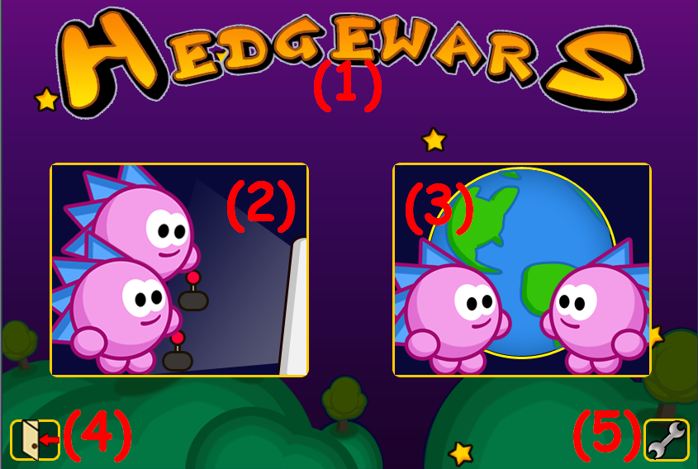
Here is a short description of each button in the main menu (navigate with the mouse and left-click in order to choose; this is in all sections and subsections of the main menu except the weapons set-section):
- Credits – here you can see who's behind this great game
- Local mode – enter local game mode section (see chapter 4)
- Network mode – enter network game mode section (see chapter 4)
- Exit – don't click on that :)
- Game configuration – here you can edit various game options like video, sound, create teams etc.
You can also see small tips when your mouse's cursor goes over each button. Since point 1,2,3 and 4 are covered in following chapters (actually 1 and 4 are not but there's not need to explain what are these), let's take a closer look at the configuration menu.

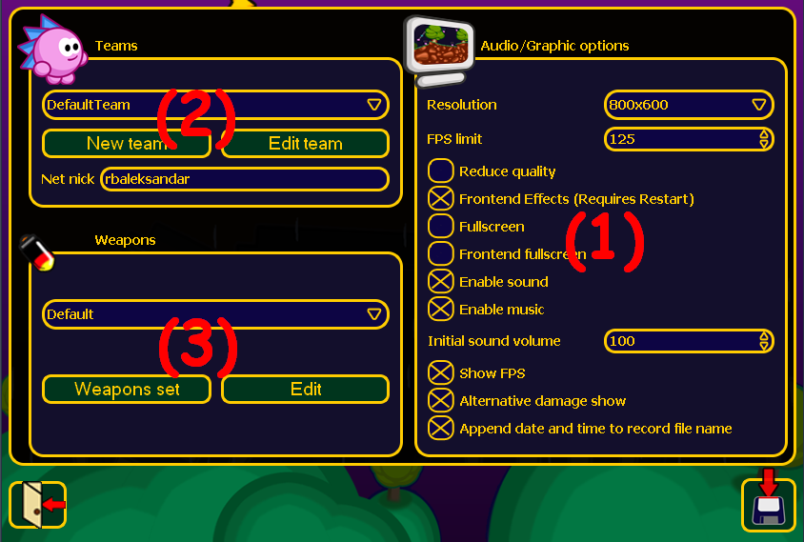
- Audio/Graphic options
Here you can change your resolution in order the game to look cool on your screen, limit the FPS (=frames per second), turn on/off frontend effects, reduce quality, change window- mode(fullscreen or windowed) etc. Turning some of these options might help you solve different game issues like problems with the sound, very low performance (see chapter 8, section Troubleshooting), but also enhance the gameplay. Something that might not be clear from the beginning is the options alternative damage show and append date and time to record file name. The first one is a gameplay enhancement that shows alternative damage – if your hedgehog falls off a cliff or something like that, it'll take damage when it hits the ground. In order too see what damage it took, enable this option. The second interesting option is associated with the recording of demos (see chapter 7, section Recording demos). It simply appends the date when the demo was recorded so that you can easily find a demo and show it to your friends as a proof that you've beaten some great champion.
Tip for busy people: play in windowed mode (fullscreen disabled). By doing this you can work something else while waiting for your next turn or just waiting for the game to finish and start over again (in network game).

- Teams
In this section you can choose your nickname (see chapter 4, section Network) and/or create a team. To enter a nickname just click on the text field and write something. When it comes to teams it's good to be mentioned that in all releases there is one default team, but you might want to edit it or simply create new ones (important to have at least 2 teams including the default team in order to be able to play in local game mode against AI or a human).
- Create teams
Click on the New team-button. Following screen should appear on your screen:

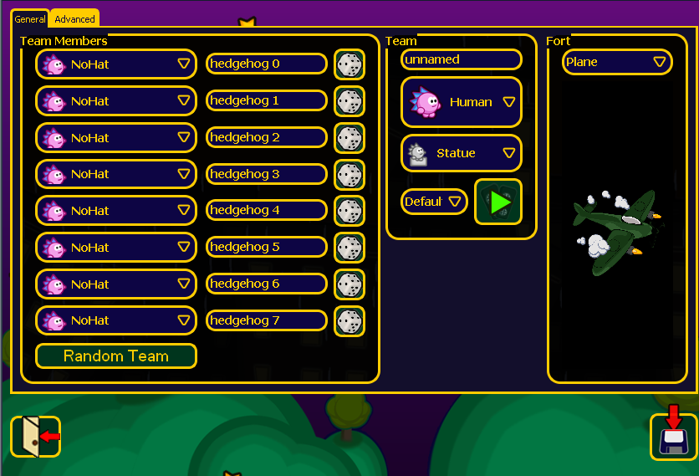
The first window is about General settings – team members' names, team's name, hats, voice pack, graves, forts and AI. A little explanation is needed here when it comes to hats. Unlike Worms (for example) HW offers a unique method for customizing each and every member of a team. The hats are sort of masks that cover your hedgehog and make him unique (see chapter 10, section Creating game contents). You can choose different hat for each member or the same hat-style for the whole team – it's up to you. To select a hat click on one of the combo boxes and then click again on the hat you like to present the n-th member of your team. Next to the lists of hats there are text fields for the names. If you are lazy and don't want to loose precious time on figuring out how to call your hedgehogs, click on the die next to the text field and the game will pick up a random name (from an implemented list of names). With each click you'll get a different (hopefully) name. If you are really lazy, you can click on the Random Team-button and the game will pick up a random team (names and hats only; from an implemented list of teams). To make each team even more unique, you can choose it's name (in the Team-section in the middle), choose a grave(this appears when one the team's hedgehogs gets killed (not drowned!)) and voice pack (the way the hedgehogs from this team speak; press the button with green arrow to hear a sample). An interesting and very important option is the AI-option. You can either choose that this team will be controlled by a human, or controlled by AI (5 difficulty levels, where level 1 is the easiest and level 5 – the toughest). Another thing you can do is choose a fort (see chapter 4).
The second window is about Advanced settings – key binds.

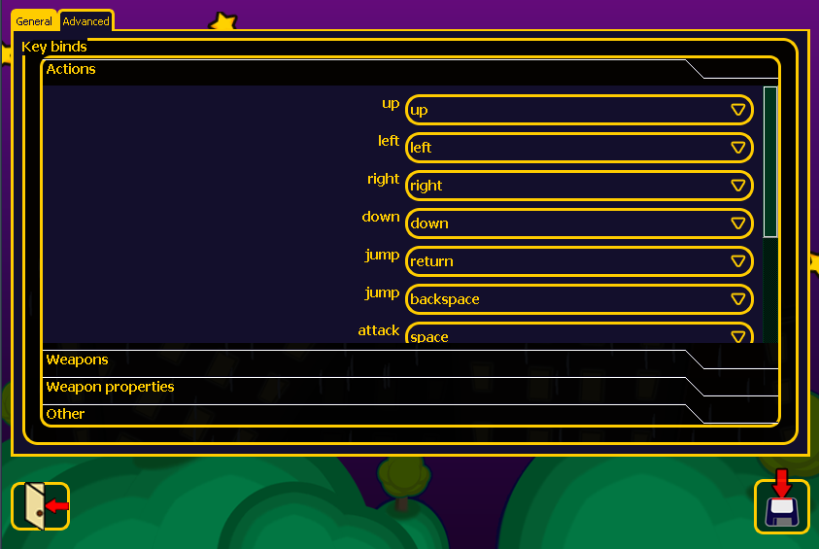
It is recommended not to touch this section if you're not sure what and how, because changing these settings might make your team almost unusable during a match and you really don't want this to happen, do you? Here you can modify the keys (key binds or also called hotkeys) you'll be able to use with this team during a match. Click on one of the tabs (Actions, Weapons, Weapons properties or Other) and choose from the combo boxes the keys you want to use. Again – be careful what you modify here!
- Edit teams
Click on the Edit team-button. Everything is the same as Create teams with the only difference that here you edit an already existing team and don't create a new one.
If you delete a team, you cannot restore it (default team can't be deleted though). You'll have to create a new team with the same settings, if you want to have it back the way it is.

- Weapons
From the combo box you can choose a weapons set – a set of weapons that will be available when a match starts (crate drops are not included here). You can create or edit sets (editing is just like creating but you edit an already existing set; you can store an edited set as a new one). Deleting sets is also possible unless it's the default one. This section should look like this:

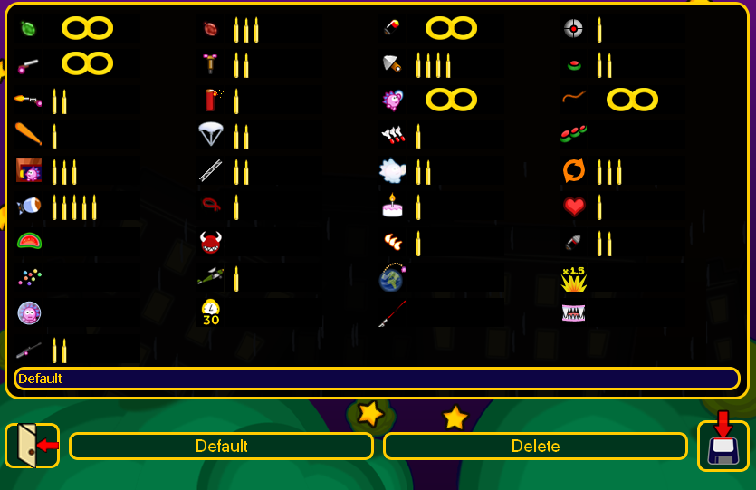
As you see there is a big table of different weapons. Next to each weapon there is a bar which indicates the ammo you'll have when the game starts (later in this chapter I'll explain how to disable curtain weapons at all during the whole match). Left-click increases the ammo, right-click decreases it unless you have reached the end (infinity or none). In this case you start from the none/infinity. There are 9 levels of ammo-amount (no bullets means no ammo, infinity bullets means infinity ammo):
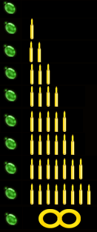
Under the table there is a text field where the name of the set is displayed. You can rename it if you want. Choosing a name that describes the content of the set is a must when playing with human opponents. Example: you want a set with infinite grenades. Then you should name your set “Grenade Set” or similar in order for the other players to get the idea what will be included at the beginning of the match and if they don't like it – ask you to change it. The Default-button sets all ammo-values to their defaults (the ones that are in the default weapons set). The Delete-button deletes a set. If you delete a set, you cannot restore it (default set can't be deleted though). You'll have to create a new set with the same settings, if you want to have it back the way it is.

4

Game modes. Setting up a game

Like many games HW has to game-modes – local and network. As you've already read in the previous chapter, these two are available directly from the main menu.
- Local – this mode provides game to be played on one computer either against AI-controlled opponents, or humans, or mixed. There are three available local modes – Simple Game, Hotseat multiplayer or Training. You can also watch recorded demos (see chapter 7, section Recording demos).

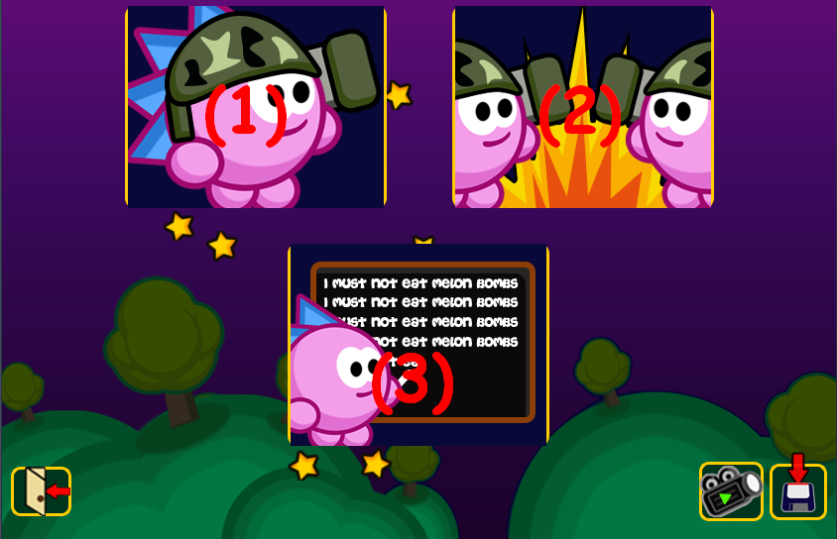

- (1)Simple Game – this is for those of you who don't want to make all the configure-this-configure-that or are novices in HW. It's a quick game where you face one AI-opponent (with average difficulty level), your team is the default one, the AI-team is a random one. It's like a glimpse through a pasty shop's window. Just one simple click and the action starts.
- (2)Hotseat multiplayer – here you can play either against AI-controlled opponents or fight your friends in front of the same computer. Much more advanced than Simple Game, but it's worth it.

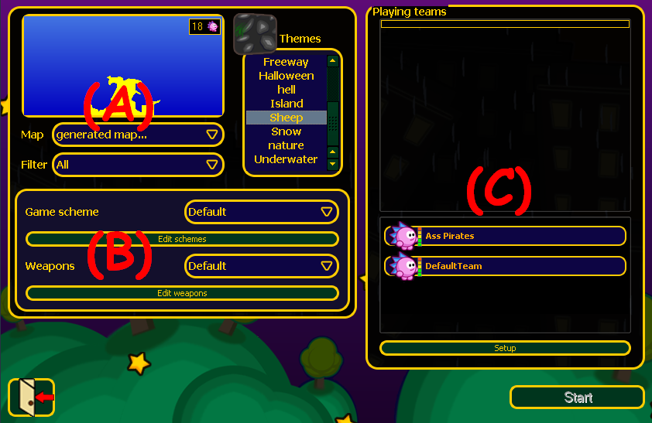
(A)Maps and themes – here you can pick a map and/or a theme you want to play. Only generated maps support themes (see chapter 10, section Creating game contents). A generated map is a randomly picked up map with variable size) from an implemented list of maps. You can set a filter if you want the game to choose a specific type of generated map(see Appendix A – Map types for detailed description of the different types of maps) by size. Have in mind that according to the size of a map, the game allows a limited number of hedgehogs on it. The maximum is 36 by large maps. The smaller the map is, the less hedgehogs it can “contain”. A preview of each map (no matter if it's generated or a standard map) is available in the big window. On it's right you can see a list of themes with a small window for a preview on it's top.
(B)Game scheme/Weapons:
Game scheme – choose from different game modifiers and basic settings. This menu should look like this when you first open it:

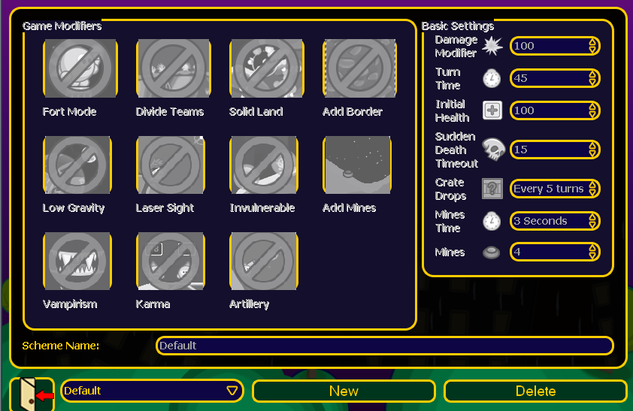
It happen pretty often people to ask: “Why can't I edit anything here?!” Well, the answer is pretty simple actually – this is an implemented game scheme. You can't edit it, you can't delete it. If you want to have another scheme either pick another one from the already implemented (see Appendix B – Implemented game schemes types) or create a new one.. To create your own game scheme click on the New-button. This section should look like this now:

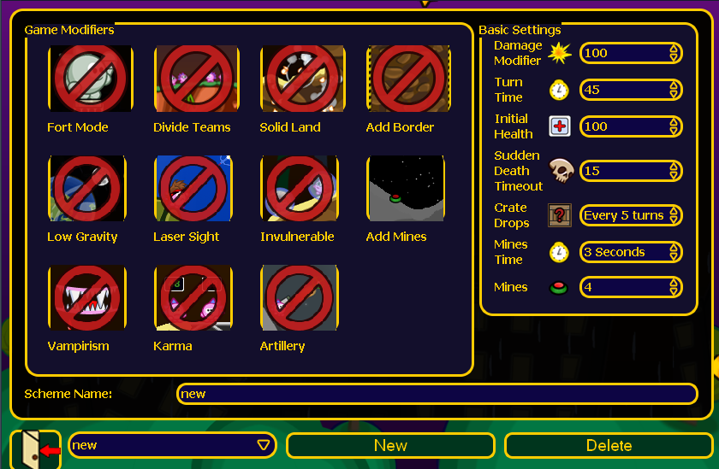
A little explanation is needed here. Modifiers and settings in this section affect all teams on the map. First there are all sorts of game modifiers:
    - Fort Mode – when activated, the game “joins” the forts of each team (the same forts you've chosen when creating each and every team) in one big map.
    - Divide teams – when activated, the game divides the teams in two halves – enemies and foes (depends on the point of view who's who actually).
    - Solid land – when activated, the game makes the ground where the action takes place indestructible. The ground can only be pierced by weapons such as the Desert Eagle.
    - Add Border – adds a border around the map (like in a kind of aquarium). This automatically makes airstrikes useless since they bounce off the border. You can climb the borders with ropes. You can't go beyond the outside the frame.
    - Low Gravity – when activated, all hedgehogs and weapons act as if the Low Gravity utility has been activated. Last during the whole match.
    - Laser Sight – when activated, laser sight can be used. This makes aiming a LOT easier.
    - Invulnerable – when activated, enables invulnerability for the whole match.
    - Add Mines – when activated, mines are added to the map.
    - Vampirism – when activated, vampirism is enabled all the time.
    - Artillery - when activated, the game anchors your hedgehogs so that they can't move but only shoot.
Basic settings are also available:
- Damage Modifier – set the percentage of damage a hedgehog takes when hit or falls. The greater percentage you set, the greater the damage will be by all weapons and alternative damage.
- Turn Time – set the time for a turn of all players (by turn is meant the period when you can move your hedgehog around and/or shoot).
- Initial Health – set the amount of health, which all hedgehogs start with.
- Sudden Death Timeout – set the time after which Sudden Death starts. Sudden Death is when times up and all hedgehogs on the map start loosing health. In addition to that the water level starts rising.
- Crate Drops – set the period of time after which a create with a weapon/utility will be dropped.
- Mines Time- set the time after which a mine on the map explodes. The shorter the period is, the faster a mine explodes when activated.
- Mines – set the amount of mines on the map when the game starts.
The saving of a scheme happens automatically. To delete a scheme, click on the Delete-button.
(C)Playing teams – here you choose which teams will play and how many hedgehogs each team will consist of (see chapter 6). Under the main frame here you see a list of all teams that can play. A team can consist of no less than 1 member and not more than 8. According to the map and number of teams that will take part in the game, adjustments to the amount of hedgehogs has to be made in order the game to start. A game starts when there are at least 2 active teams (this means teams placed in the Playing Teams-list). Teams of players can be grouped in alliances by selecting the same color (left-click on the color palette on an active team) for each member of the alliance. There should be at least 2 teams from different alliances. Otherwise the game automatically finishes in the first few seconds announcing the victory of all hedgehogs on the map. To remove a team from the Playing teams-list just click on it and it will automatically drop down as inactive. You can also make modifications on your teams by clicking the Setup-button. Modifications on teams of other players (unless you're not admin and the players you want to modify are AI-controlled) are not possible.
- (3)Training – a set of predefined mission to show you the basics and some advanced tactics.

- Network – this mode gives you the opportunity to play over a network of computers either against AI-controlled opponents, or humans, or mixed. There are two available network modes – LAN or Internet.

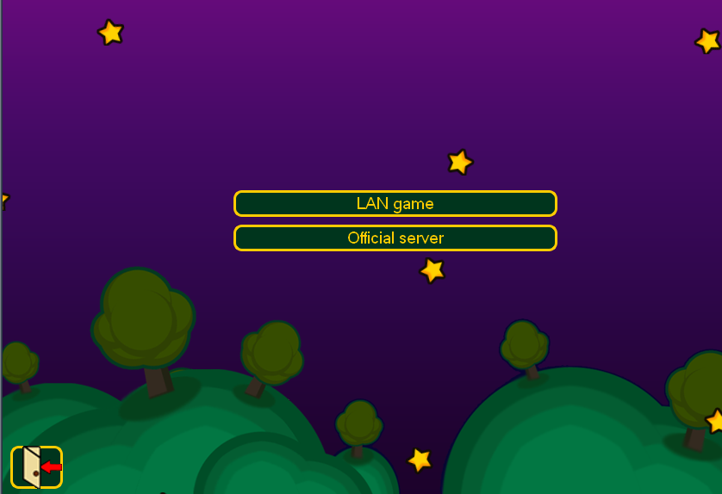
- LAN – play games with friends in a local area network. The LAN-section should look like this:
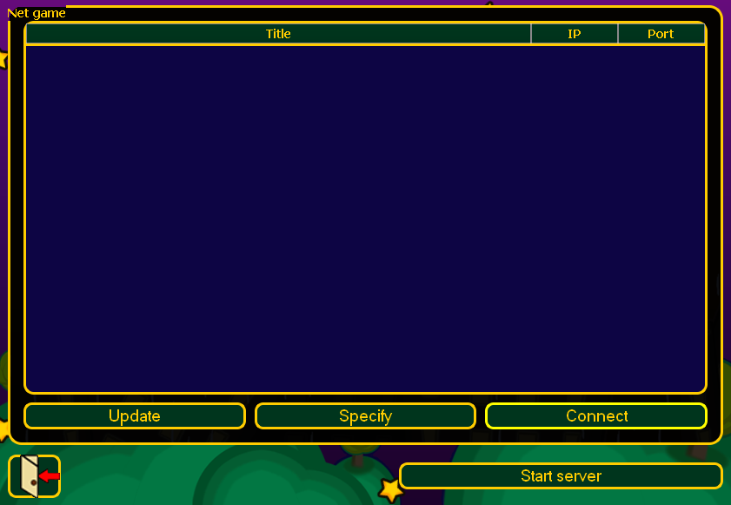

The big frame here is the list of the available LAN-networks. In order the host/join a game over LAN you have to have an active LAN (logical, isn't it?)
- Hosting a game – click on the Start server-button (you have to have the hedgewars-server executable!). Following window should appear on your screen.
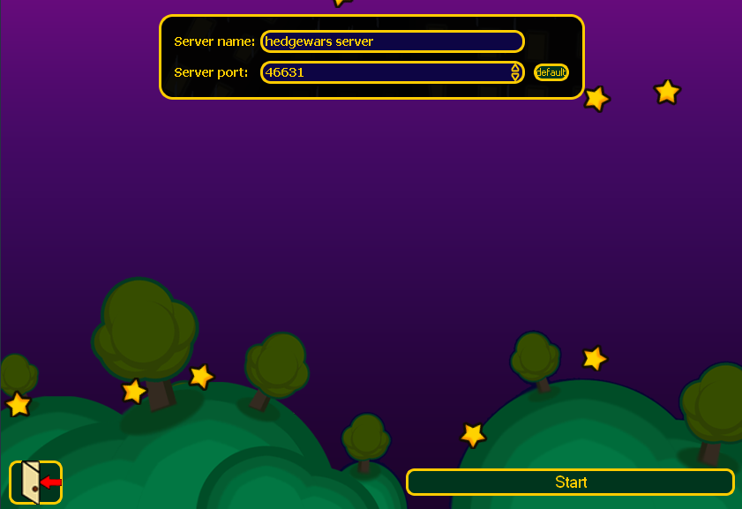
As you can see for the image above you can specify the name and the port of your server. The default value is 46631. Make sure your firewall doesn't block this port
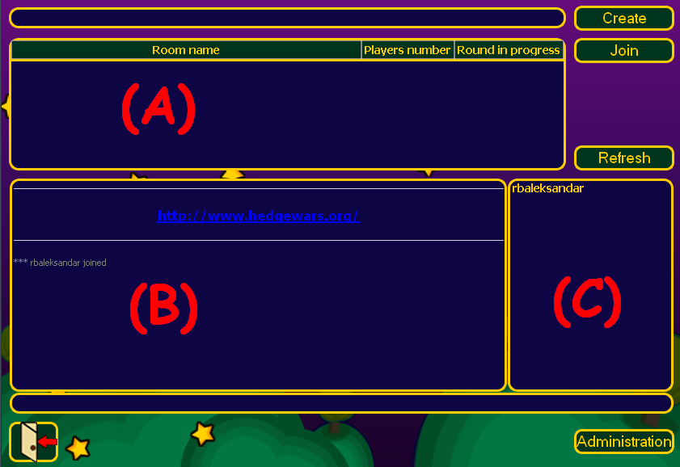
from access. Otherwise other players won't be able to join your game. Once you're done here click on the Start-button. Following should appear:

This is the so called lobby. It's something like the foyer in a hotel – you can chat with people, arrange fights (well, in a decent hotel it's not good to do that) etc. The actual fights don't take place in the lobby though. There are special rooms for this purpose. If there are no rooms, no-one can play anything. To create a room enter it's name in the long text field on the top of this section. Then click Create.
(A)This is the list where all available rooms on this server are displayed. Rooms can be sorted by name, number of players and if a round in room X is in progress or not.
(B)Small statistics of who joined the lobby and who left it. Here is also the place where the IP of a player is displayed (see below in (C)).You can also specify a title-message (by default it's www.hedgewars.org). In order to do that, click on the Administration-button on the bottom at the most right. In the text field you can enter a message like “Welcome to my first server! Hope you enjoy it!”. To set the message click on the Set Message-button. Messages also support basic HTML. This means that you can make your message look better with different formatting.
( C)The list of all players currently online. Here you can get important information like the IP of a player (this is actually more important when playing over the internet), the version of the game the player is currently running (very important because of compatibility issues; players with different versions of the game can't play together because with each new release new features are added) and the place where he/she is. It has the following form:

nickname [IP address] game_version place*
*lobby/room

You can get this information by right-clicking on a player from the list and choosing the Info-option from the drop-menu. As you might have noticed there is another option in this menu called Kick. This is used to (virtually) kick this player out of the server. Only the administrator of the server has the ability to do that.
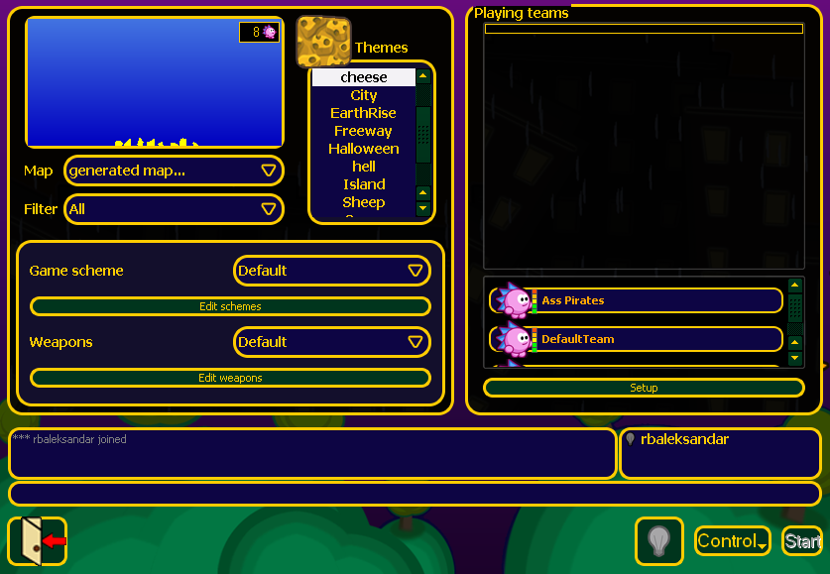

As mentioned above in order to play a match, you have to enter a room. After clicking on the Create-button, following section will appear in front of you:
The big frame on the left with maps, themes, game schemes and weapons is exactly the same as in a hotseat local mode game. The same goes for the list on the left for playing teams, choosing the amount of hedgehogs in each team, it's color etc. The frame below them is the chat window along with the list of players who are currently in this room. Right-clicking on a player gives you the same drop-menu as in the lobby. The Info-option gives you the following the message-board:

nickname [IP address] game_version room name_of_the_room

The ability to kick players is present here too. The only person who can kick players from a room is it's creator. A room-administrator isn't equal to a server-administrator!
In the list there is a small light bulb next to it. It indicates if the player is ready for the game to start. You can start a game only if you have 2 active teams in the Playing teams-list. You can use this even to play a hotseat local mode game, although there is not much of a point in doing that. On the right you see a player that is not ready. On the left there is a player that is ready (light bulb is yellow):
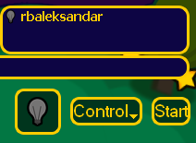
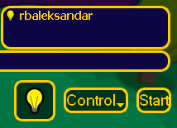
To show that you're ready, click on the big Light bulb-button next to the Control- button.
The Control-button gives you the opportunity to restrict Joins and/or Team Additions. When the first is activated, no more players can join your room. The second one disables the ability of any player in this room to add more teams in the Playing teams-list. The second one can be used for spectators – people who don't want to play with you and the other players in the room but just to watch the match. A spectator can't interfere in the game. Only chatting is possible. When everyone is ready, the game can be started (by the room-administrator) by clicking on the Start-button.
- Joining a game – clicking on a room in the list with rooms will automatically put it in the text field above so that you can then join it by clicking on the Join-button. Joining a room where a round (match) is in progress will automatically make you a spectator.
- Internet – almost the same as LAN-mode with the only difference that you can play with a guy from Guam, while you live in Iceland.

5

Interface, controls, weapons and tactics
or how to achieve eternal glory

Note: This chapter is of top priority for each and every player. Without it you won't be able to control your hedgehogs, to use weapons properly etc. This leads to certain defeat. All key binds are the default binds. If you have changed something in the Advanced options menu of the game, you can go and reset them in order to strictly follow the instructions in this chapter. Or just compare the changes that you have made and the default key binds in order not to get confused.

It is a good idea to start a small game with weak opponent in order to learn all that follows fast and by heart.
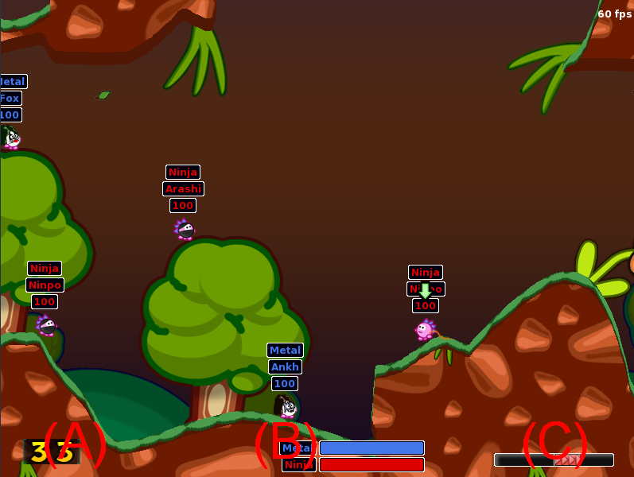
- Interface - the interface of HW is pretty much the same as the one that can be seen in the Worms series (Armageddon and World Party).
(A)Timer – indicates the elapsed time of the current turn. Can be changed from the basic settings of the game in the Game scheme-section. The time is in seconds where the minimum is 1 second (not really useful to set this value) and the maximum is 99 seconds.
(B)Players – shows the name of all players (not spectators!) that are currently in the match (even those who have been defeated). Each teams is indicated not only by its name but by its color too (unless n teams are in an alliance; in this case teams from an alliance have the same color). The bar on the right of the names indicates the total health of your team. This means if you have two teams A and B with two hedgehogs in each, and in team A first hedgehog has 30HP (HP stands for health points) and the second – 70HP, and in team B first hedgehog has 50HP and the second – 50HP, the health-bar will be with the same length. Therefore you can't see the HP of each hedgehog in team X. You have to look at the health-status above each
hedgehog:
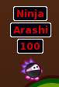
First line displays the name of the team which the hedgehog belongs to. Second line shows the name of the hedgehog. Third line is the health-status.
(C)Wind direction – shows in which direction the wind blows. Very important to look at while using weapons affected by the wind (see section Weapons). There are two wind directions in the game:
To the left: To the right:
The current active hedgehog is indicated by a bouncing arrow. Like this:


HW also provides announcement system – short comments about what happened on the map (someone got killed for example) or a weapon that you have chosen. Announcements are placed on the top of the screen right in the middle. They look like this:

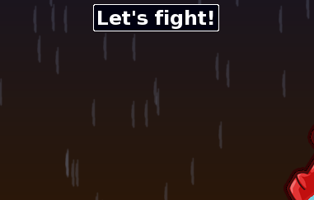
The last but not least is the weapons' table. You can call it any time when it's your turn by right-clicking. It'll appear on the right at the bottom of the game widnow:

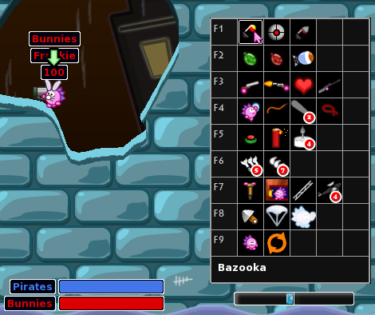
The table is divided in three sections – weapons, utilities and others. The first column shows you which key binds you can use to call the corresponding row. If you press F1 for example with each pressing the game will pick up the next weapon in this raw – Bazooka, UFO and finally Drill Rocket. You can loop through the whole role as long as the turn is not over. You even don't have to open the weapons' table in order to do that. The announcer always tells you which weapon you have picked. So even if the table is closed you will know that you have a Bazooka for example. The key binds are really useful but you have to know the table by heart (which weapon in which row and column is).
When you have made your choice of a mass destruction weapon or a simple utility, your hedgehog will look like this (in case you've picked an aiming weapon/utility; other wise only a weapon/utility will be displayed in the hands of your hedgehog without a back-sight indicator; back sight indicator is used to show you in which direction you're aiming):
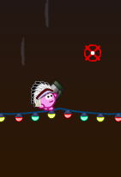
(see section Game controls and basic movements)
Another thing that is good to know (especially for network gaming) is the chat. It appears on the top left corner and looks like this:
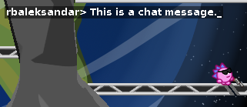
Activate it with T and type in the message you want to send. Then press Enter to send it. For now the only way to exit the chat is to send empty message (if you have written something but don't want to send it, just delete it with Backspace and write something else or press Enter to exit the chat).
Note:Here's something that you must not forget especially in critical moments when there are a few seconds left – activating the chat redirects the whole keyboard input to the chat. In simple words – you can't move, can't shoot, can't pause, can't exit the game (in a normal way) because the chat grabs what you've tipped with the keyboard. Pressing P for example (key bind for Pause) will not pause the game but write a p in the chat. But the timer's countdown does not stop. You have to deactivate the chat in order to continue playing!
This is all you need to know about the GUI. Now let's take a closer look at the different types of objects in the game – ground, water etc. Like in the real world a hedgehog usually walks on the ground. This is the so called solid ground. Here is an example:
Note: The red line is drawn along the surface where a hedgehog can walk and roll.


The maps that support themes (see chapter 10, section Creating game contents). There is also a set of objects placed on random places on the solid ground. In fact these objects have the same properties as the solid ground – they can be walked on and destroyed by weapons.

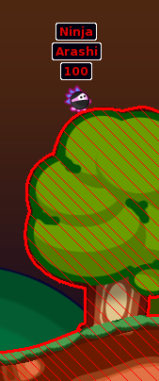
The red lines show you where you can't walk (of course the air is also included). You can only walk on the thick red line that is on the surface of the solid ground/object. Ground (including the objects that are placed on it) is the “playground”. In most cases when a hedgehog leaves the ground it was hit or is drowning. So sticking to the ground is a good thing to do. Really steep slopes and vertical cliffs can be climbed only with Rope, sometimes with Gravity utility etc.
Water is something that you should avoid. Although some weapons can deal with it, a hedgehog can't swim. Therefore if a hedgehog falls into the water, it drowns. You might want this to happen to your opponent's team-members, but not to yours. Even approaching water is dangerous. You might say: “Oh, I think there's a little piece of solid ground there. I will jump on it.” In most cases this doesn't work the way you want it to work. An AI- opponent always knows where the ground ends. But you don't.
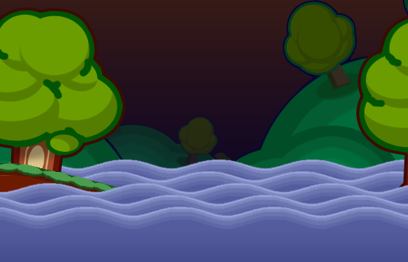
2. Game controls and basic movements – after you have learned what and where, it's time to learn the how. Game controls are very important for an almost flawless game. As mentioned in the section about configuring a team, controls can be adjusted to your needs. If you feel that some key bind bothers you, you can easily change it. Here is a list of all default key binds:
Note: You might experience some problems with the controls according to what keyboard you are using. This key binds work excellent on most layouts. But there are some where you
will find the corresponding key very difficult or keys are swapped (like German layout where Y is the usual Z and Z is the usual Y in an English layout). In such cases it is good to make your own key binds which doesn't make you sweat every time you want to find use a specific key bind.

Move up | Up Arrow
Move down | Down Arrow
Move left | Left Arrow
Move right | Right Arrow
Forward jump | Enter
Upward jump | Backpace
Upward and backwards jump | 2 times Backspace
Shoot | Space (hold or single press); Enter(secondary weapon)
Ammo menu | Right mouse click
Slot 1 | F1
Slot 2 | F2
Slot 3 | F3
Slot 4 | F4
Slot 5 | F5
Slot 6 | F6
Slot 7 | F7
Slot 8 | F8
Slot 9 | F9
Timer 1sec | 1
Timer 2sec | 2
Timer 3sec | 3
Timer 4sec | 4
Timer 5sec | 5
Chat | T
Chat history | `
(Un)pause game | P
Confirmation | Y
Denial | N
Quit | Esc
Volume up | 0
Volume down | 9
Change mode (windowed/fullscreen) | F12
Show active hedgehog | H
Capture current screen | C
Precise aim | Left Shift
Put Target Marker | Left Click
Toggle hedgehog's info | Delete
Show/Hide weapons' table | Right Click
Select weapon [while weapons' table opened] | Left Click
Speed-up demo playback | S

Note: If you're fond of color-systems, you might want to take a look at Appendix C.

In HW you can move in all directions. But in order to do so, you'll need a specific utility for example to go straight upwards. Otherwise your movement is limited to basic ones like walking or jumping on the surface of the solid ground.
- Weapons – last but definitely not least come the weapons in HW. In the following section you will the basics of how to aim, how to place your hedgehogs (in order to avoid damage for example), description of each and every weapon/utility in the game, how to use it properly (in order to avoid killing yourself for example), some tips&trick plus advanced offensive/defensive tactics.
First of all let me explain the difference between weapons and utilities. The weapon's main purpose is annihilation of your opponents (well, in the wrong hands they'll do bad things to you too). The utilities are used mainly for overcome obstacles, defensive tactics etc. This doesn't mean that weapons cannot be use as utilities and vice versa. But both offer things that the others don't have (there are some exceptions of course).
Before you learn more about the different weapons, it's good to know how to aim and shoot. You've already learned how to select a weapon and how your hedgehog looks when it has picked up one (with/without backsight). Now here is something that confuses most novice players – it seems as if the hedgehog is shooting from the center of its body and not from the weapon itself. Yes, that is actually true. The weapons are simply graphics attached to the body of the hedgehog. They are not “weapons” (I know, it's a little bit confusing). A very good example for this is the Desert Eagle:

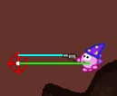
The green line shows the actual aiming. The blue one shows the aiming as it seems to be. That's why always look at the crosshair when aiming. Forget about the barrel of the weapon.
All fire-weapons, some utilities and superweapons have crosshairs. Weapons like Mines, TNTs etc. or utilities like Parachute, Girders etc. don't require aiming (well, actually they do but kind of different art of aiming).
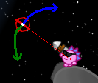
In order to aim (determine shooting angle) you have to use Arrow-keys to move the crosshair up or down. To move it up (on the image on the next page it's marked with blue arrow) press Up Arrow, to move it down (on the image on the next page it's marked with green arrow) – the Down Arrow.
HW gives you the opportunity to set the shooting power too. This option is available only by firing-weapons (not all) and grenades. Under shooting power I mean the power you give your shell/grenade (by grenades it's called throwing power and you have 1.5sec until you reach its maximum) before it leaves your hedgehog's hands/weapon's barrel. All weapons and utilities are activated by hitting the Spacebar (some utilities have secondary shooting which is activated by pressing Enter). You can define the shooting power by holding the Spacebar. A bar will appear coming from your hedgehog:

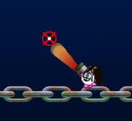
The longer you hold the Spacebar, the more power your shell/grenade will gain. Though after approximately 2 seconds the bar will be full and the shell/grenade will be released automatically. So be careful how long you press the key. The shooting power is a very important but undeservedly neglected aspect of the art of shooting. To hit your target you need to “calculate” the proper shooting power AND the wind's direction.
Wind is another important factor and things can turn very bad for you if you don't pay enough attention to the wind direction bar (see section Inteface). The things you have to know about the wind are: direction and strength. The stronger the wind is, the greater the deflection of your shell/grenade from its main trajectory will be (yes, it's too complicated but only at the beginning).
Now a small summary of what you have in mind before firing your weapon:
- shooting angle
- shooting/throwing power
- wind direction
- wind strength
If you manage to calculate (measure with your eyes of an expert) correctly, you will hit your target with 100% accuracy and maximum damage.
Don't be sad when you see how good the AI-opponents are (especially on higher difficulty levels). They are AI after all and they can calculate the trajectory of the shell/grenade/whatever with insane accuracy. Even great players (*cough* like myself *cough*) often make mistakes since the shooting as simple as it might seem to be at first sight is actually very difficult to master.
You can find a table with description of each weapon/utility and a small guideline with tips to each of them in the two other files that go with this manual. For full description (plus some jokes) and guidelines visit the HW-Wiki on the official HW-site.
- Advanced tactics – here you will learn some advanced tricks and how to use weapons/utilities most efficiently.
- Girder – you can do really a lot of things with a girder. Except the obvious to build cute little houses, it can also be used for some advanced offensive and defensive tactics.
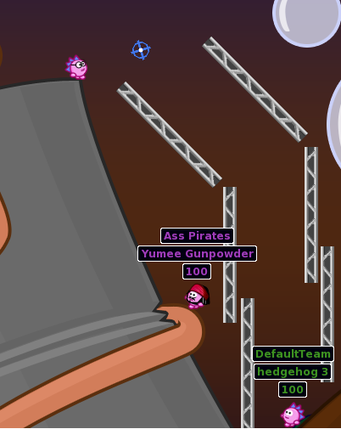
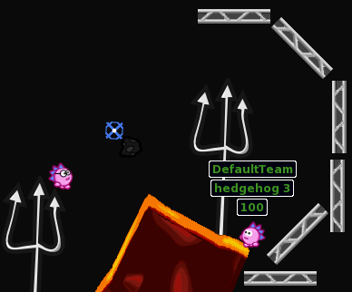

The image above shows the so called girder furrow/funnel (this name popped up in my mind and I think it describes best what's going on here). Such constructions are great when you want to use grenades but your target is somewhere, where it's practically impossible to throw your load of death. Also very good to “gather” your fire (from a ballgun for example) and direct it even towards one single target leaving it's surrounding (except the ground below it) completely intact.
Most players use girders for building shelters to protect their army from (mostly) air-land attacks (like Air Strike). Here's a small example of a girder shelter.

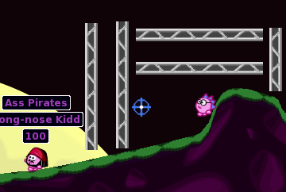
Notice that there are small gaps between the girders. Usually it's good to leave as bigger gaps as possible depending on where you are and if someone can squeeze between the girders. By doing that your shelter will last longer when hit by a shell or rocket because the air cushions “consume” part of the explosion's power. If you put the girders too close to one another each hit will make a big hole in 2 or more of them and soon there will be a big crack in your defense. A nasty way to make an opponent “waste” a turn is to block his way like this:

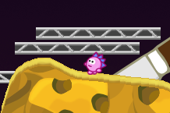
You have to put the girders in such way that there is very little space to maneuver and shoot. Girders near each other can “transport” the power from an explosion. So if you block someone and shoot with a Bazooka for example at the girders, it'll still deal damage to your victim. No matter what he does, he'll waste a hole turn trying to escape from this trap (especially if the hedgehog's near the water and SD has started). If you're trapped like this, you will definitely loose a turn (unless you switch hedgehogs) but better make most of it. Best way to escape is to teleport yourself on a save place. If there is still enough ground below you, it's good to dig in this direction in order to avoid taking damage from hits on the girders. A Tourch will do the same but you will become even more vulnerable if you manage to escape, since now your enemy can make a direct hit.
- Rope – rope is definitely the most used utility in the game. But it's also the most difficult to master. That's why I'll describe it's usage in a detail.
Note: Best maps so far for training how to use the rope are Bamboo and Cogs. There you can practice all techniques that follow below.
First technique which might also be considered a basic one it the accelerated swing. To shorter the rope gets, the faster you'll swing. And gain even more speed you can make the more advanced version – accelerated swing with bounce. This is when you swing of a hanged up object or ground, shortening the length of your rope when you hit the wall below the “cliff”. This will make your hedgehog bounce off and thus gain even greater acceleration enough to make a great arc in the air. Below is phase one – the swing towards the wall below the hanged up object (in our case – a crab):
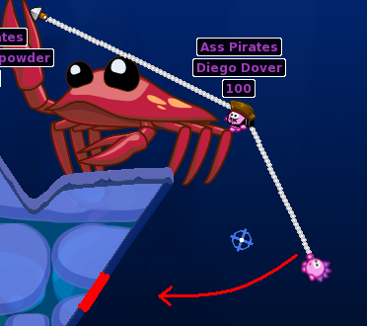
The red thick line marks the spot where your hedgehog will hit the wall (approximately) and bounce off. It hits the wall and turns to the opposite direction:

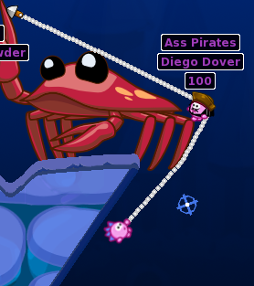
Second phase (last longer) is the bounce off and using the length of the rope plus the edge of the object to gain speed (the light blue arrow shows shortening/lengthening):

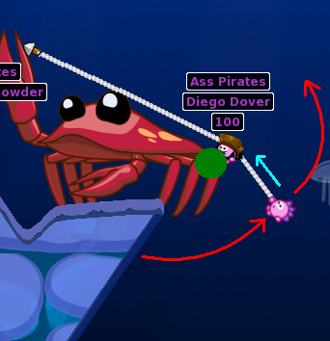
Shorten the rope shortly almost immediately after hitting the wall. The moment when your rope is in a horizontal position is critical. If you shorten the rope too fast you will end up with bottom in the dirt. Keep going up.
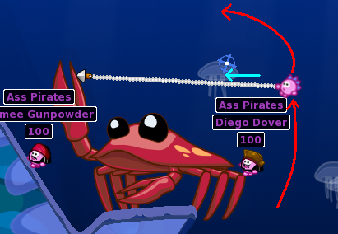
Another critical moment is when you should start lengthening your rope. It's hard to give an accurate angle (and besides – who's going to measure the angle with a protractor on the screen?) but it's a little bit before the rope's angle hits 80º:
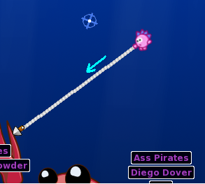

You have to be really fast here because after you reach 90º you'll have very few time to lengthen your rope to its full length.
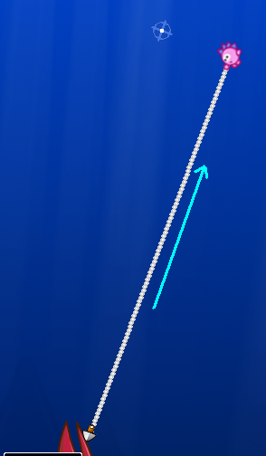

You can fire a weapon at any time by pressing enter. Have in mind that you can't define the shooting/throwing power of the weapons. To show off you can even stand vertically on the rope for a couple of seconds and maybe send a chat message. :P
Another trick is the sliding. It works best on flat terrain or on a slope with small angle. Usually the point where you fix the rope's end is right above the hedgehog(s) you want to slide and bump into, and make them slide too. But when you get used to this technique, you'll find that any fixation point in the proximity of your target is good. The point of the whole exercise is to pile the enemy's hedgehogs together or just push them off a cliff. First aim at a spot almost vertically above your target:

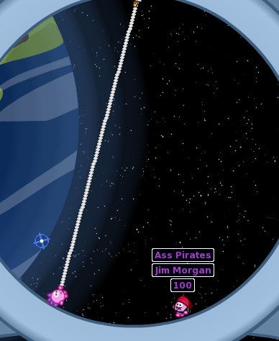
Then shorten the rope a little bit so that you don't bump into your target (it won't budge at this stage so there is no point in doing that):

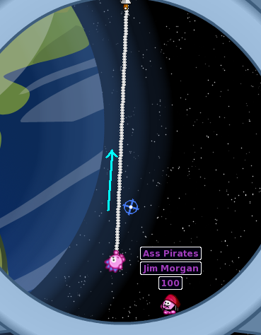
Now swing a little bit:
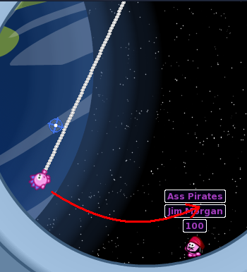
In order to avoid bumping into any obstacles on your way, regulate the length of your rope:
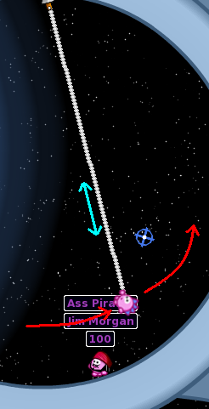
The point when you release the rope and start flying in the air is critical. Since it's varies according to what terrain you're playing on, I can only tell you this – you have to be not too far from your target and not too high above the ground because you will miss and/or hurt/kill
yourself for nothing.
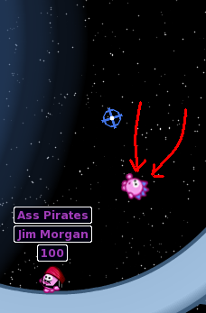
You will fly towards your target and (hopefully) hit it.

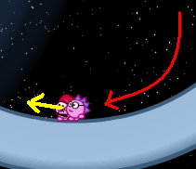
Now there is a tiny problem here – you slide along with your victims. So if you were too fast when you've released the rope, the slide-speed will be too great. You gain control over your hedgehog when it has stopped sliding. So if you've decided to slide and push a bunch of enemies of a cliff, you might as well follow them in the abyss below. It's only then worth it, when there are 2-3 and more hedgehogs to kill.
Note: The Bamboo map is the greatest range to practice this trick.
Last but not least there is something which will especially make the fans of Tarzan happy.
If you have enough rope and a long stretch between you and your victim, use the Tarzan swing. You move very fast across the map but it's very dangerous. Before you do anything there is something very important you have to know – you can't aim your rope directly while swinging. The aiming is controlled by the game. A little explanation is needed here:

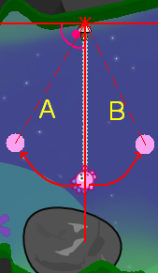
Imagine there is a straight line that points vertically downwards (towards the center of the Hedgeworld :P). When you aim to launch the game memorizes the angle and when you start swinging, the crosshair remains with the same angle in relation to the vertical line. It only changes the sides A/B. If you swing to the right (marked with B), the crosshair will go go on the right side too (with the same angle when launched the rope!) and vice versa (the left is marked with A. No there are other positions with the rope that change the direction that your crosshair points to. You have to determine them by yourself (or look here). Here are some examples:
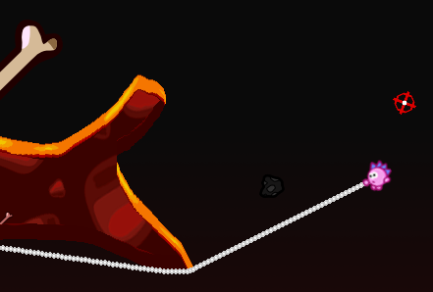
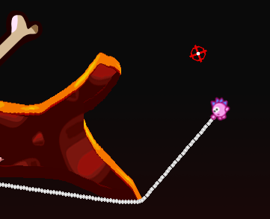
It is important to know that because before you shoot with the rope you have to look at the whole route that you plan to swing across. If you don't do that, at some point you might get in a situation where your rope is with a wrong angle and there is no ground nearby where you can land, correct it and try again. Usually small angles will do you good but you'll be moving slower. Tarzan swing is nothing more than a normal swing but you do it more than once. Once you have figured out what angle would be most suitable for the terrain you want to swing across, shoot with the rope and swing in the direction you want to go. When the crosshair changes its position and it suites your needs, drop the rope and fly a certain distance (according to how fast you swung and how long your rope is). Now here's the trickiest part – the right moment to launch the rope again. Some people often forget that the rope's length has a maximum (with other words – it's not infinite) and besides – there might me water underneath. You have to have in mind this. If you fly too much and downwards, if your next fixation point is somewhere above you, you might miss it and fall. A too short rope is also a great pain – as you've read already – the shorter the rope is, the faster it swings. So you might look like a small punchbag and will be some time before you gain control over Tarzan.
Note: With a very small angle you can even climb vertical terrain but it's very slow.
The rope has something else to offer that might make things worse or better. It can hook to sharp edges.

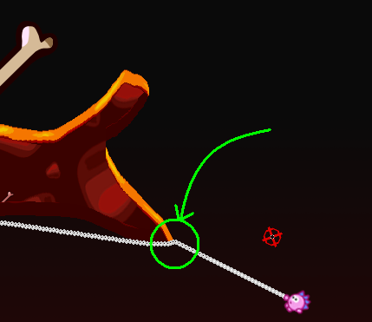
In the hands of an unprofessional player this is a big hold-back in using this utility. When the cord of a rope hooks to a fixing point, this spot instantly becomes the new main fixation point. In plain text – as if you have hooked your rope to this spot by the launching and not to the previous.. Of course it becomes shorter and shorter with each fixation point (since a rope has a fixed length as mentioned above). The new point has all the specifications of the main rope's hook – you can spin around it, you can swing etc. To the moment of writing this sentence I've never seen someone who unhooked such thing. It can only be removed if you unhook the hole rope. It's considered to be a bug since even if the object where the hooking was disappear, it still acts as if it hasn't. It'll be removed in 0.9.12 (inside information ;)).
Last but not least there is the jump and hook technique, which can be used to shorten the distance to your target and thus make it possible to hook to it with the rope, which otherwise is impossible. For shortening horizontal distance use the forward jump (press Enter). For vertical shortening use the single or double vertical jump (hit once or twice Backspace). While in the air, you can shoot with the rope. It can even make a landing from a great height smooth and without loosing a single HP if you hook your rope on time.
Note: It's better to define the shooting angle while you're still on the ground but you can still define it in mid air. This is very dangerous, since aiming is much slower than falling (unless you don't use Low Gravity, which kind of “evens” the difference).

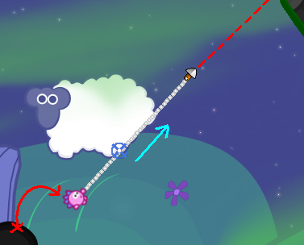
On the image above you can see a small example how this looks and works. In this and in all situations it is good to have at least a faint idea how long your rope is since a jump shortens the distance between you and the target with a few centimeters. Not much but sometimes enough.
In the real world when you throw yourself in the sea while holding on a rope you can pull yourself out of the water. In HW it doesn't work like that. If you swing and your hedgehog gets wet, it'll drown.
- Drill Rocket – not too much to say here. There is one thing you must not neglect and one defensive tactic. The thing you always have to remember before pulling the trigger is the distance between you and the ground you want to drill through. This distance is about one hedghog's size between you and the ground.
Drill Rocket is also used for making drill rocket bunker.

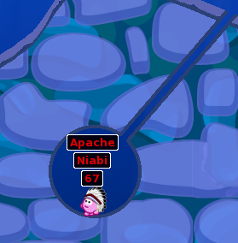
Use the Drill Rocket to make a hole in the ground (preferably somewhere far from the water if you want to stay there longer than 1-2 turns). Then teleport in it on the next turn. You have to hide in the corners since the whole the drill rocket has left isn't enough big for a grenade to go through but big enough for a shot with Desert Eagle for example. And the size of the entrance is the big disadvantage – you either have to dig yourself out of the bunker or teleport outside it.
Beside these issues the Drill Rocket acts just like a normal bazooka.

- Napalm Strike – the most difficult to master Air-Strike weapon. It's due to the fact that it's affected by the wind. There are two ways to master the secret of accurate attack with this weapon – you have to be either a physician or have a good eye that can “presume” where the fire will land. The first one I don't need to describe. The second you'll get with lots of practice. Beside the wind direction and strength have also in mind the direction from which you call the strike.

6

Internet gaming

The strength of HW is in multiplayer no doubt and in particular – action over the internet. You can have fun with people all over the world and not leave your cozy chair.
Note: Detailed information on how to create and configure a room can be found in chapter 4, section Network.
In order to play over the internet you need at a 56 kbit/s modem (with less is also possible). Connection problems can be determined by an animated icon on the upper left corner looking like this:


Check your firewall configuration before reporting a bug. Hedgewars needs 46631 TCP port opened at the server side. LAN must also provide UDP datagrams broadcasting for automatic server discovery.
There is one other thing you should know if you want to play on the official server (see chapter 9) – a registration is required. For now it's not an important issue but in the next releases enhancements will be made and you will definitely want to have an account, which is the same as your account for the forums on the official HW web site. You can register here.
You can make your own server of course. Then you won't need a registration.
The Log In-screen looks like this (appears after you press Official Server in Network game mode):

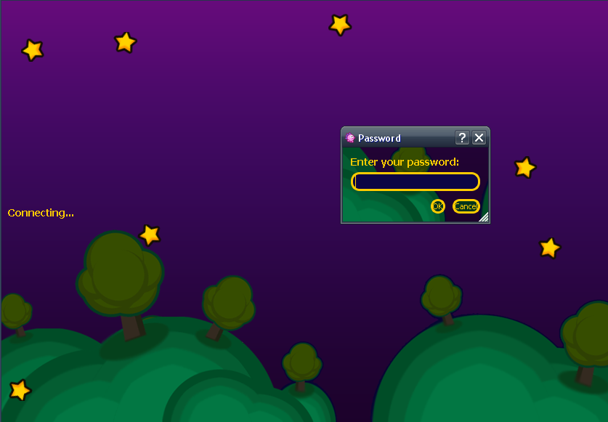
Now you may be asking yourself: “Okay, the account is the same but how does the game know my nickname?” Simple – as you remember you define your nickname in the Options menu. To use your account, enter the exact same name there that you use to log in in the forums. Example – I'm user_name and my password is 123456890. So in the Options menu in the field for a nickname I'll write user_name. When the Log In-screen appears, in the password field I'll enter 1234567890 and hit the OK-button. And you'll land in the official server's lobby. The rest is like in a normal LAN game (see Appendix D for chat commands).

7

First match and all that follow

Finally the chapter you've all been waiting for – the action itself. You should be well prepared by now and still you'll find out that there are so many things that you don't know (maybe due to the fact I missed to mention them here) and go wrong. Don't worry. It's normal. With the time after each game you'll feel more and more confident (except if you loose each and every one; in this case you might get depressed and commit a suicide. DON'T DO THAT! It'll be lying on my conscience for a long time and your angry spirit will haunt me). I've probably mentioned this before but mentioning it again won't hurt but help – ask and answer. If you need help, most players will be glad to help you. I like doing that. You can even arrange a meeting with a more experienced player and create a training room just to learn this or that. If you can help, don't keep your knowledge for yourself. Share it. Most people are grateful when someone shows them how something's done the right way.
For a start it's good to start with single player mode to practice what you've learned in the previous chapters. As you already know AI opponents can be from very easy to very tough. Start from the lowest difficulty level and keep increasing it until you gain at least some experience.
The multiplayer mode is the next stage. I prefer playing over the internet because of the following reasons:
- There are more people with different level than your friends. It's good to play with your friends of course. Don't get me wrong. But you can also play with unknown opponents over the internet.
- You make acquaintance with people all over the world.
- You can find a great variety of techniques that I didn't introduced here. It's impossible to summarize all the knowledge the community has.
When you enter a lobby, a room or are in the middle of a match, it's always nice to have a chat.
- Etiquette – behavior is the most important thing when you communicate with someone. Shouting and abusing others won't do you good. You can even be banned (over IP), if one of the moderators finds out. Be polite, be supportive. The player's bad behavior makes a bad advertisement of this wonderful game. Think about that. Abusing someone in a language you think he doesn't understand is a big mistake too. It happened to me not once that someone swore at me in his/her language without knowing that I can swear in so many languages. I might not know how to speak or write in it.
- Demos – HW gives the opportunity to record a demo of your game in order to save the precious moment of your victory (you surely don't want this for a defeat ;)). Demos are recorded automatically and only if you finish a match (with defeat or victory). If you're in the middle of a match, it's saved as a Saved game.

~/.hedgewars/Demos/ [in Unix/Linux systems]
%USERPROFILE%\.hedgewars\Demos\ [in Windows systems]

The file extension is .hwd_#, where # is an integer. To watch a demo (demos on the official site can be found here) copy it in the folder that I mentioned above (mind the OS you have). You can enter the demo section of the game by entering the local mode and clicking on this button:


After a game finishes or you copy a new demo-file in the demo-folder you can, a demo should appear in the list (when copying a file into the demo-folder, you have to reenter the demo-section in order the list to be updated):
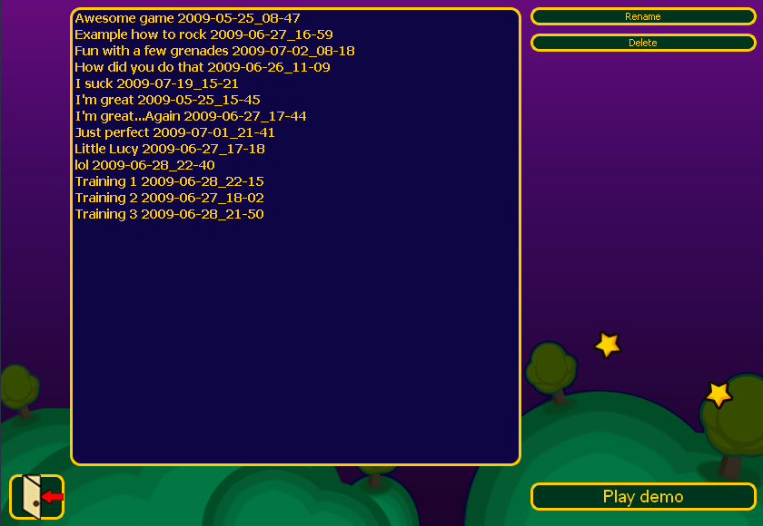
You can delete and rename your demos. In the Options menu, section Audio/Graphic options there is an option to append the date and time of the demo when it was recording. Very useful if you want to sort your demos by date. Demos can be played by selecting one from the list and pressing the Play demo-button. While playing a demo, you can press (and hold) the S-key in order to accelerate the playback.

8

FAQ, troubleshooting and support

Most things in this chapter come from the official site (and the forum) plus a summary of things mentioned in this manual. It'll be constantly updated even when all other things are finished since new questions occur almost every day
- How do I compile Hedgewars? - See chapter 1.
- How do I...(in-game key bindings)? - see chapter 5, section Game controls and basic movements
- CMake can not find my Qt installation! - tell cmake a path to Qt manually:
$ export QTDIR=<qt dir>
or
$ cmake -DQT_QMAKE_EXECUTABLE=<path to qmake>
- How can I watch demos I downloaded from 'Demos'? - see chapter 7
- Network game does not work for me! - see chapter 6
- Why Qt4? - Because we need a portable and easy to maintain GUI widgets for game and options setup.It would be unreasonable to maintain self written GUI. Currently we have no time and manpower for it. We are interested in developing a game and game features, not to implement our own crossplatform GUI library/framework.
- I'm experiencing resolution issues with my dual monitor setup and an nVidia card under Linux, what should I do? - X.org supports something called "MetaModes" which lets you define different resolutions in X that you can instantly switch to without having to restart the X server or log out.This example is only tested on a computer with an integrated nvidia chip, but should work with different graphic devices as well. Find the resolution of your two monitors. If you're using nvidia, run nvidia-settings, then click the X Server Display Configuration item in the tree view to the right. Your screens will show the correct resolutions in the left part of the configuration window. Note down the resolutions. Open your xorg.conf file (usually located in /etc/X11/xorg.conf), and scroll down to the "Screen" section. Comment out any "Option MetaModes ..." lines you may have there already, by putting a # in front of the line (should look something like "#Option MetaModes ..." after commenting it out). Now, paste the following line in, under the line you commented out:
Option "MetaModes" "1680x1050,1600x1200;NULL,1600x1200;1680x1050,NULL"
The "MetaModes" setting is a semicolon-separated list of resolution combinations, defined like this:"screen1,screen2". The first resolution should be whatever your currently running.
The second one in this example says that "screen1" should be off (NULL), and screen2 should run with 1600x1200 resolution. Use whatever you had in your nvidia-settings for your screen2.The third one is similar, just the other way around, with the second monitor (screen2) turned off, and the first monitor running with maximum resolution. The fourth one in my example has the first monitor running with max resolution (because it is the one that provides the *tallest* resolution (1050)), and the second one running the highest resolution that gives me the same height (1050). Now, save this file, log out and log back in. (You may have to restart your X server - if so, just log out, press CTRL+ALT+Backspace, and then log in). In hedgewars, in the screen section, you should now have several resolutions to choose from! As an added bonus, you can also change the resolution on the fly in your Desktop Environment (GNOME or KDE), by running the screen resolution configuration tool (krandrtray in KDE, "Screen Resolution" in GNOME), and switch to any of the metamodes you defined earlier.
- Why is Hedgewars asking for a password when I try to login on the gameserver? - see chapter 6.
- How can I help making Hedgewars better? - see chapter 10
- Where can I get help if I encounter any problems/glitches? - try the Forum and/or IRC channel.
- When will the next release be ready? - asking occasionally for the next release will only annoy the developers' team. They do their best and this takes time. And yet releases are usually each couple of months. Be patient – it's worth the waiting.
- I have an ATI video card and have glitches and decreased performance (a couple of fps).- use the Search-field in the forum. You'll find a lot of threads about problems with ATI cards.
- Why not C++ but FreePascal? - The author of the engine knows this best and he developed the game from nothing. Feel free to rewrite the whole game and if you wish – share it with the community.
- Client eats up quite a bit of CPU. - Problem is combination of your (Ubuntu Jaunty) system due to QT 4.5, Pulseaudio, and SDL.
- I think there is a bug in the game/Game crashed.. How can I report this? - Go to the .hedgewars-folder, there you can find the demo/save of the game you played (in the Demo- or Save-folder) and a txt-file called debug0, which contains the debug log of the last game. Don't start a new game after the problem occurred without securing this file. It'll be rewritten and all the information on the problem will be lost. Now go to the forums/IRC channel and post the content of the debug-file and provide a link where the developers can download your demo/saved game from (you can upload the demo-file directly from the Demo-section on the official HW site). Problems are generally discussed the Support- or Audio&Graphics-section in the forum.
- I have a suggestion how to improve the game/web site. - Go to the forum on the official site and post either in Feedback & Suggestions or in Hedgewars Website discussion.
- What system can I install HW on?/What are the minimum system requirements? - see chapter 2.
- Why is this game so incredibly awesome?!? - *sigh*
- Why are you SO COOOOOOL?!? - *sigh*...*sigh*...*sigh*

9

Hedgewars Tournament and online ladder

A couple of months and idea was born. It was about one of the greatest tournaments in the history of Hedgeworld – The Hedgewars Tournament (HWT for short). (pause for effect) It's competition between life and death, courage and fear...For now only 2 tournaments took place but it's already become a tradition to organize this event every couple of months.
There is a place in the forum for discussion and organization-things about the HWT. You can find it here. As all tournament the HWT has also a set of rules, which may be changed before each tournament but not while it's running. In the News-page on the official site you can see when a tournament will take place. The matches are played on the official server. The usual rules are as follows:
- A party must consist of two players and two teams.
- Each player must use his login (same password as on the website).
- Each Team will have two Hedgehogs, so it will be 4 Hedgehogs per side.
- AI teams are forbidden.
- Players must use the same teams all the way through the tournament.
- Each match will be the best of three games.
- Each game will use the default weaponset, health and turn time.
- Each match will take place on a randomly generated map.
- Every game in a particular round must be played within the week scheduled for that round.
- When a match is finished, players must announce the winners in the forum thread at the end of this post.
- Demos should be saved for matches where possible.
- Matches not played within the week schedule will be subject to review, if one or both parties are found to be responsible for the match not being played, that player/players will be knocked out of the tournament.
- If a network problem occurs whilst both parties have more than 3 hogs the match will be replayed.
- If a network problem occurs when one party has less than 3 hogs, the party with the most hogs at the time is declared the winner.
- If a network problem occurs when both parties have the same hog count (but less than 4), the party with the most combined hp will win.
- Organising when a match is played within the week scheduled is down to the players.

It is common practice to arrange matches in CET-time (Central European Time) because the server is in Europe and besides – there are player from all over the world. On the next page you'll find how the HWT-ladder looks like, where <term> is the time for a current round and <winner> is the winner of the tournament.
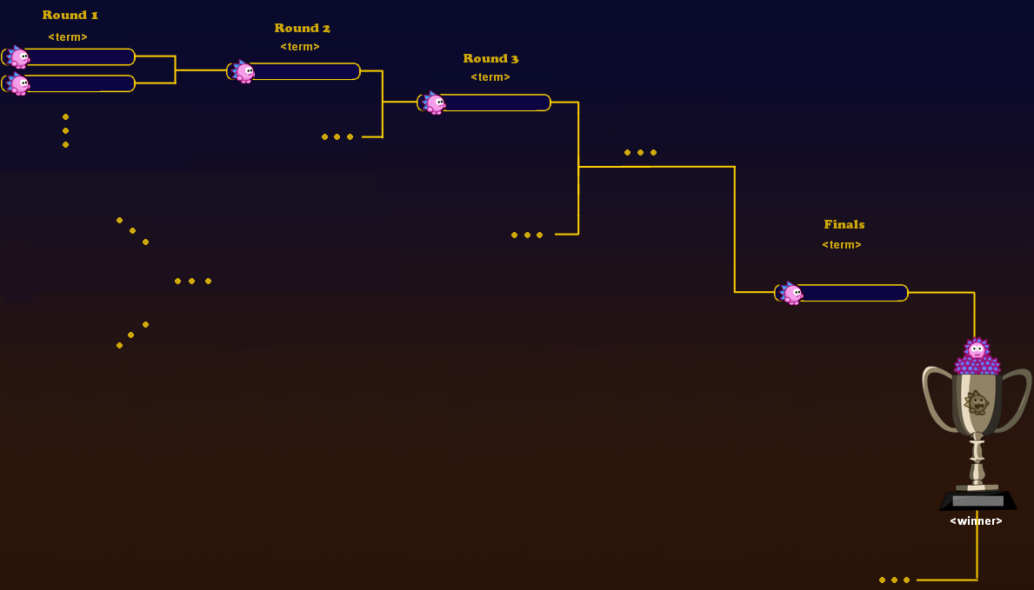
There are two types of tournament – Player vs. Player and Team vs. Team (where the number of members of team is defined before the start of the tournament.

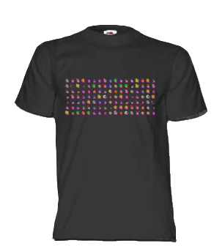
There is a plan for the near future that experience points will be gained when playing matches on the official server (including those from a HWT) and statistics will be added to each player making it possible to go up the HW classification unlocking special abilities. But for now it's just the joy, fame and glory you'll have to chew.

Appendix A

Map types

As mentioned in chapter 4, section Maps and themes, the filter provides you with the ability to sort maps by sizes and forms. It's very important to know the difference between the different types of maps for the following two big reasons (there are more small ones of course):
- They limit the number of hedgehogs on the map (therefore the number of players too).
- They make some weapons useless.
Have in mind that a team can have maximum 8 members. For now there are 5 types(hh=hedgehog):
- Small – a map of this type can contain no more than 8 hedgehogs. Such maps are mostly preferred for 1vs1-matches or quick matches since there is not much solid ground and after a few rounds there is none left. These maps offer almost no place to hide. Possible team-dispensation for hotseat or network game:
- 8 teams with 1hh each
- 2 teams with 4hh each
- 4 teams with 2hh each
- Medium – still not enough solid ground therefore maximum 18 hedgehogs can fight on a map of this type.
- 6 teams with 3hh each
- 3 teams with 6hh each
- 2 teams with 8hh each
- team-dispensation for small maps can be applied here too
- Large – the biggest possible type of map. It can contain maximum 36 hedgehogs. This offers a large space for insane battles. Such maps are preferably played by many players wit h large teams since if you play them with a few hedgehogs and teams, it'll take a while before you reach your opponents by foot. Possible team-dispensation for hotseat or network game:
- 6 teams with 6hh each
- 9 teams with 4hh each
- 4 teams with 8hh each
- team-dispensation for medium and small maps can be applied here too
- Cavern – can contain maximum $$ hedgehogs. This type of map is also great for bunker-play where each team builds a bunker (with Girders). It's also great for rope-play since there is a ceiling above the whole battlefield (with a border around it). Notice that because of the ceiling (and mostly because of the border) air-strike-based weapons are useless here.
- Wacky – this type of map is for maximum $$ hedgehogs. It looks wacky with a couple of sleeves where you can move. A ceiling (with border) is presented here too so like cavern maps great for rope- and bunker-play. Air-strike-based weapons are useless.

If you decide to play with teams with very few hedgehogs, you might consider increasing the initial health from the game schemes (see chapter 4, section Game scheme/Weapons). For cavern and wacky maps you have limited space above. So in case of SD you won't be able to climb beyond the border no matter how many Girders you have.

Appendix B

Implemented game schemes

Before you start playing a match it's good to know what will it include/exclude. Factors such as Turn Time, Sudden Death Time-out, Crate Drops etc. are very important and if you define them bad, you might even end up with an unplayable match. Again – implemented schemes can't be modified or deleted. Each scheme has a weapon set that goes with it. It's preferred to play use the intended set but you can also use a different one.
- Default – all game modifiers are disabled except Add mines. The basic settings are as follows:
- Damage modifier - 100%
- Turn Time – 45sec
- Initial Health - 100HP
- Sudden Death Time-out - 15sec
- Crate Drops – Every 5 turns
- Mines Time – 3sec
- Mines – 4
Note: Good for novice players.
- Pro mode – all game modifiers are disabled. The basic settings are as follows:
- Damage modifier - 100%
- Turn Time – 15sec
- Initial Health - 100HP
- Sudden Death Time-out - 15sec
- Crate Drops – Never
Note: Good for advanced players.
- Shoppa – all game modifiers are disabled except Solid Land. The basic settings are as follows:
- Damage modifier - 100%
- Turn Time – 30sec
- Initial Health - 100HP
- Sudden Death Time-out - 50sec
- Crate Drops – Every turn
Note: Good for exercise with the rope. Best map that goes with this is the Rope map.
- Basketball – all game modifiers are disabled except Solid Land, Invulnerability and Low Gravity. The basic settings are as follows:
- Damage modifier - 100%
- Turn Time – 30sec
- Initial Health - 100HP
- Sudden Death Time-out - 15sec
- Crate Drops – Never
- Mines Time – 3sec
- Mines – 4
Note: Good for training how to use Baseball-bat and Low Gravity. Best map that goes with this is the Basketball map.
- Minefield – all game modifiers are disabled except Add Mines. The basic settings are as follows:
- Damage modifier - 150%
- Turn Time – 30sec
- Initial Health - 50HP
- Sudden Death Time-out - 15sec
- Crate Drops – Never
- Mines Time – 0sec
- Mines – 50
Note: Good for training how to manoeuvre. Best maps that go with this are flat maps.
Using your own schemes is great but – as already mentioned – use descriptive names for them so that it can give the players a lead towards what the match will the match be like.

Appendix C

Default key binds

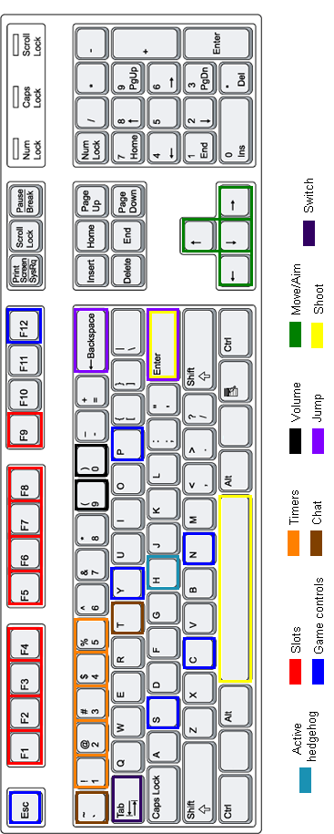

Appendix D

Chat commands
Following chat command are available:
Note: Words in bold are not part of the command but a message (typed by the user (if in the left column) or displayed on the screen (if in the middle or right column). All commands in the table (except the first one) have to be typed and executed while your hedgehog is active (all these happen to the selected one). Be careful how you use them. ;)

Command | Description | What you see...
/me message | *USER message | 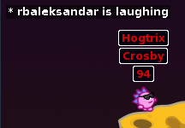
“message” | Speech bubble with the message | 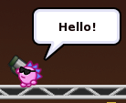
'message' | Thought bubble with the message | 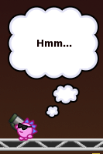
-message- | Action bubble with the message | 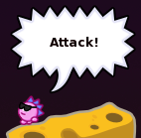
/hsa message | Speech bubble with message at the moment of shooting | 
/hta message | Thought bubble with message at the moment of shooting | 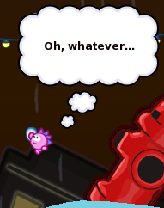
/hya message | Action bubble with message at the moment of shooting | 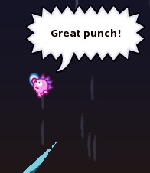
/sad | A very sad looking hedgehog | 
/rollup | Hedgehog rolls over | 
/hurrah | A happy hedgehog saluting | 
/wave | Hedgehog waves at you | 
/ilovelotsoflemonade | Hedgehog pees | 
/shrug | Hedgehog shrugs | 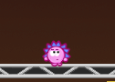
/juggle | Hedgehog juggles with small colorful balls | 
/newgrave | Hedgehog drops a grave (the one set for the team). You can drop as many graves as the time allows you | 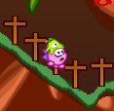

Index

Credits

All who helped in creating Hedgewars
Developers:
Engine, frontend, net server: Andrey Korotaev <unC0Rr@gmail.com>
Many frontend improvements: Igor Ulyanov <disinbox@gmail.com>
Many engine and frontend improvements: Derek Pomery <nemo@m8y.org>
Drill rocket, Ballgun, RC Plane weapons: Martin Boze <afffect@gmail.com>
Frontend improvements: Martin Minarik <ttsmj@pokec.sk>
Frontend improvements: Kristian Lehmann <email@thexception.net>
Mac OS X port: Vittorio Giovara <vittorio.giovara@gmail.com>
Art:
Finn Brice <tiyuri@gmail.com>
Joshua Frese <joshfrese@gmail.com>
Stanko Tadić <stanko@mfhinc.net>
Julien Koesten <julienkoesten@aol.com>
Joshua O'Sullivan <battysausage@hotmail.co.uk>
Nils Lück <nils.luck.design@gmail.com>
Hats: Trey Perry <tx.perry.j@gmail.com>
Sounds:
Hedgehogs voice: Stephen Alexander <ArmagonNo1@gmail.com>
Finn Brice <tiyuri@gmail.com>
Jonatan Nilsson <jonatanfan@gmail.com>
Daniel Martin <elhombresinremedio@gmail.com>
Translations:
Brazilian Portuguese: Romulo Fernandes Machado <abra185@gmail.com>
Bulgarian: Svetoslav Stefanov
Czech: Petr Řezáček <rezacek@gmail.com>
Chinese: Jie Luo <lililjlj@gmail.com>
English: Andrey Korotaev <unC0Rr@gmail.com>
Finnish: Nina Kuisma <ninnnu@gmail.com>
French: Antoine Turmel <geekshadow@gmail.com>
German: Peter Hüwe <PeterHuewe@gmx.de>
Italian: Luca Bonora <bonora.luca@gmail.com>
Japanese: ADAM Etienne <etienne.adam@gmail.com>>
Polish: Maciej Mroziński <mynick2@o2.pl>, Wojciech Latkowski <magik_15l@poczta.fm>, Maciej Górny
Russian: Andrey Korotaev <unC0Rr@gmail.com>
Slovak: Jose Riha
Spanish: Carlos Vives <mail@carlosvives.es>
Swedish: Niklas Grahn <raewolusjoon@yaoo.com>
Ukrainian: Eugene V. Lyubimkin <jackyf.devel@gmail.com>
Special thanks:
Aleksey Andreev <blaknayabr@gmail.com>
Aleksander Rudalev <alexv@pomorsu.ru>
Natasha Stafeeva <layout@pisem.net>
Adam Higerd (aka ahigerd at FreeNode)

GNU Free Documentation License

GNU Free Documentation License
Version 1.3, 3 November 2008

Copyright (C) 2000, 2001, 2002, 2007, 2008 Free Software Foundation, Inc.
<http://fsf.org/>
Everyone is permitted to copy and distribute verbatim copies of this license document, but changing it is not allowed.

0. PREAMBLE

The purpose of this License is to make a manual, textbook, or other functional and useful document "free" in the sense of freedom: to assure everyone the effective freedom to copy and redistribute it, with or without modifying it, either commercially or noncommercially. Secondarily, this License preserves for the author and publisher a way to get credit for their work, while not being considered responsible for modifications made by others.

This License is a kind of "copyleft", which means that derivative works of the document must themselves be free in the same sense. It complements the GNU General Public License, which is a copyleft license designed for free software.

We have designed this License in order to use it for manuals for free software, because free software needs free documentation: a free program should come with manuals providing the same freedoms that the software does. But this License is not limited to software manuals; it can be used for any textual work, regardless of subject matter or whether it is published as a printed book. We recommend this License principally for works whose purpose is instruction or reference.

1. APPLICABILITY AND DEFINITIONS

This License applies to any manual or other work, in any medium, that contains a notice placed by the copyright holder saying it can be distributed under the terms of this License. Such a notice grants a world-wide, royalty-free license, unlimited in duration, to use that work under the conditions stated herein. The "Document", below, refers to any such manual or work. Any member of the public is a licensee, and is addressed as "you". You accept the license if you copy, modify or distribute the work in a way requiring permission under copyright law.

A "Modified Version" of the Document means any work containing the Document or a portion of it, either copied verbatim, or with modifications and/or translated into another language. A "Secondary Section" is a named appendix or a front-matter section of the Document that deals exclusively with the relationship of the publishers or authors of the Document to the Document's overall subject (or to related matters) and contains nothing that could fall directly within that overall subject. (Thus, if the Document is in part a textbook of mathematics, a Secondary Section may not explain any mathematics.) The relationship could be a matter of historical connection with the subject or with related matters, or of legal, commercial, philosophical, ethical or political position regarding them.

The "Invariant Sections" are certain Secondary Sections whose titles are designated, as being those of Invariant Sections, in the notice that says that the Document is released under this License. If a section does not fit the above definition of Secondary then it is not allowed to be designated as Invariant. The Document may contain zero Invariant Sections. If the Document does not identify any Invariant Sections then there are none.

The "Cover Texts" are certain short passages of text that are listed, as Front-Cover Texts or Back-Cover Texts, in the notice that says that the Document is released under this License. A Front-Cover Text may be at most 5 words, and a Back-Cover Text may be at most 25 words.

A "Transparent" copy of the Document means a machine-readable copy, represented in a format whose specification is available to the general public, that is suitable for revising the document straightforwardly with generic text editors or (for images composed of pixels) generic paint programs or (for drawings) some widely available drawing editor, and that is suitable for input to text formatters or for automatic translation to a variety of formats suitable for input to text formatters. A copy made in an otherwise Transparent file format whose markup, or absence of markup, has been arranged to thwart or discourage subsequent modification by readers is not Transparent. An image format is not Transparent if used for any substantial amount of text. A copy that is not "Transparent" is called "Opaque".

Examples of suitable formats for Transparent copies include plain ASCII without markup, Texinfo input format, LaTeX input format, SGML or XML using a publicly available DTD, and standard-conforming simple HTML, PostScript or PDF designed for human modification. Examples of transparent image formats include PNG, XCF and JPG. Opaque formats include proprietary formats that can be read and edited only by proprietary word processors, SGML or XML for which the DTD and/or processing tools are not generally available, and the machine-generated HTML, PostScript or PDF produced by some word processors for output purposes only.
The "Title Page" means, for a printed book, the title page itself, plus such following pages as are needed to hold, legibly, the material this License requires to appear in the title page. For works in formats which do not have any title page as such, "Title Page" means the text near the most prominent appearance of the work's title, preceding the beginning of the body of the text.

The "publisher" means any person or entity that distributes copies of the Document to the public.

A section "Entitled XYZ" means a named subunit of the Document whose title either is precisely XYZ or contains XYZ in parentheses following text that translates XYZ in another language. (Here XYZ stands for a specific section name mentioned below, such as "Acknowledgements", "Dedications", "Endorsements", or "History".) To "Preserve the Title" of such a section when you modify the Document means that it remains a section "Entitled XYZ" according to this definition.

The Document may include Warranty Disclaimers next to the notice which states that this License applies to the Document. These Warranty Disclaimers are considered to be included by reference in this License, but only as regards disclaiming warranties: any other implication that these Warranty Disclaimers may have is void and has no effect on the meaning of this License.

2. VERBATIM COPYING

You may copy and distribute the Document in any medium, either commercially or noncommercially, provided that this License, the copyright notices, and the license notice saying this License applies to the Document are reproduced in all copies, and that you add no other conditions whatsoever to those of this License. You may not use technical measures to obstruct or control the reading or further copying of the copies you make or distribute. However, you may accept compensation in exchange for copies. If you distribute a large enough number of copies you must also follow the conditions in section 3.

You may also lend copies, under the same conditions stated above, and you may publicly display copies.

3. COPYING IN QUANTITY

If you publish printed copies (or copies in media that commonly have printed covers) of the Document, numbering more than 100, and the Document's license notice requires Cover Texts, you must enclose the copies in covers that carry, clearly and legibly, all these Cover Texts: Front-Cover Texts on the front cover, and Back-Cover Texts on the back cover. Both covers must also clearly and legibly identify you as the publisher of these copies. The front cover must present the full title with all words of the title equally prominent and visible. You may add other material on the covers in addition. Copying with changes limited to the covers, as long as they preserve the title of the Document and satisfy these conditions, can be treated as verbatim copying in other respects.

If the required texts for either cover are too voluminous to fit legibly, you should put the first ones listed (as many as fit reasonably) on the actual cover, and continue the rest onto adjacent pages.

If you publish or distribute Opaque copies of the Document numbering more than 100, you must either include a machine-readable Transparent copy along with each Opaque copy, or state in or with each Opaque copy a computer-network location from which the general network-using public has access to download using public-standard network protocols a complete Transparent copy of the Document, free of added material. If you use the latter option, you must take reasonably prudent steps, when you begin distribution of Opaque copies in quantity, to ensure that this Transparent copy will remain thus accessible at the stated location until at least one year after the last time you distribute an Opaque copy (directly or through your agents or retailers) of that edition to the public.

It is requested, but not required, that you contact the authors of the Document well before redistributing any large number of copies, to give them a chance to provide you with an updated version of the Document.

4. MODIFICATIONS

You may copy and distribute a Modified Version of the Document under the conditions of sections 2 and 3 above, provided that you release the Modified Version under precisely this License, with the Modified Version filling the role of the Document, thus licensing distribution and modification of the Modified Version to whoever possesses a copy of it. In addition, you must do these things in the Modified Version:

A. Use in the Title Page (and on the covers, if any) a title distinct from that of the Document, and from those of previous versions (which should, if there were any, be listed in the History section of the Document). You may use the same title as a previous version if the original publisher of that version gives permission.
B. List on the Title Page, as authors, one or more persons or entities responsible for authorship of the modifications in the Modified Version, together with at least five of the principal authors of the Document (all of its principal authors, if it has fewer than five), unless they release you from this requirement.
C. State on the Title page the name of the publisher of the Modified Version, as the publisher.
D. Preserve all the copyright notices of the Document.
E. Add an appropriate copyright notice for your modifications adjacent to the other copyright notices.
F. Include, immediately after the copyright notices, a license notice giving the public permission to use the Modified Version under the terms of this License, in the form shown in the Addendum below.
G. Preserve in that license notice the full lists of Invariant Sections and required Cover Texts given in the Document's license notice.
H. Include an unaltered copy of this License.
I. Preserve the section Entitled "History", Preserve its Title, and add to it an item stating at least the title, year, new authors, and publisher of the Modified Version as given on the Title Page. If there is no section Entitled "History" in the Document, create one stating the title, year, authors, and publisher of the Document as given on its Title Page, then add an item describing the Modified Version as stated in the previous sentence.
J. Preserve the network location, if any, given in the Document for public access to a Transparent copy of the Document, and likewise the network locations given in the Document for previous versions it was based on. These may be placed in the "History" section. You may omit a network location for a work that was published at least four years before the Document itself, or if the original publisher of the version it refers to gives permission.
K. For any section Entitled "Acknowledgements" or "Dedications", Preserve the Title of the section, and preserve in the section all the substance and tone of each of the contributor acknowledgements and/or dedications given therein.
L. Preserve all the Invariant Sections of the Document, unaltered in their text and in their titles. Section numbers or the equivalent are not considered part of the section titles.
M. Delete any section Entitled "Endorsements". Such a section may not be included in the Modified Version.
N. Do not retitle any existing section to be Entitled "Endorsements" or to conflict in title with any Invariant Section.
O. Preserve any Warranty Disclaimers.

If the Modified Version includes new front-matter sections or appendices that qualify as Secondary Sections and contain no material copied from the Document, you may at your option designate some or all of these sections as invariant. To do this, add their titles to the list of Invariant Sections in the Modified Version's license notice. These titles must be distinct from any other section titles.

You may add a section Entitled "Endorsements", provided it contains nothing but endorsements of your Modified Version by various parties--for example, statements of peer review or that the text has been approved by an organization as the authoritative definition of a standard.

You may add a passage of up to five words as a Front-Cover Text, and a passage of up to 25 words as a Back-Cover Text, to the end of the list of Cover Texts in the Modified Version. Only one passage of Front-Cover Text and one of Back-Cover Text may be added by (or through arrangements made by) any one entity. If the Document already includes a cover text for the same cover, previously added by you or by arrangement made by the same entity you are acting on behalf of, you may not add another; but you may replace the old one, on explicit permission from the previous publisher that added the old one.

The author(s) and publisher(s) of the Document do not by this License give permission to use their names for publicity for or to assert or imply endorsement of any Modified Version.

5. COMBINING DOCUMENTS

You may combine the Document with other documents released under this License, under the terms defined in section 4 above for modified versions, provided that you include in the combination all of the Invariant Sections of all of the original documents, unmodified, and list them all as Invariant Sections of your combined work in its license notice, and that you preserve all their Warranty Disclaimers. The combined work need only contain one copy of this License, and multiple identical Invariant Sections may be replaced with a single copy. If there are multiple Invariant Sections with the same name but different contents, make the title of each such section unique by adding at the end of it, in parentheses, the name of the original author or publisher of that section if known, or else a unique number. Make the same adjustment to the section titles in the list of Invariant Sections in the license notice of the combined work.

In the combination, you must combine any sections Entitled "History" in the various original documents, forming one section Entitled "History"; likewise combine any sections Entitled "Acknowledgements", and any sections Entitled "Dedications". You must delete all sections Entitled "Endorsements".

6. COLLECTIONS OF DOCUMENTS

You may make a collection consisting of the Document and other documents released under this License, and replace the individual copies of this License in the various documents with a single copy that is included in the collection, provided that you follow the rules of this License for verbatim copying of each of the documents in all other respects.

You may extract a single document from such a collection, and distribute it individually under this License, provided you insert a copy of this License into the extracted document, and follow this License in all other respects regarding verbatim copying of that document.

7. AGGREGATION WITH INDEPENDENT WORKS

A compilation of the Document or its derivatives with other separate and independent documents or works, in or on a volume of a storage or distribution medium, is called an "aggregate" if the copyright resulting from the compilation is not used to limit the legal rights of the compilation's users beyond what the individual works permit. When the Document is included in an aggregate, this License does not apply to the other works in the aggregate which are not themselves derivative works of the Document.

If the Cover Text requirement of section 3 is applicable to these copies of the Document, then if the Document is less than one half of the entire aggregate, the Document's Cover Texts may be placed on covers that bracket the Document within the aggregate, or the electronic equivalent of covers if the Document is in electronic form. Otherwise they must appear on printed covers that bracket the whole aggregate.

8. TRANSLATION

Translation is considered a kind of modification, so you may distribute translations of the Document under the terms of section 4. Replacing Invariant Sections with translations requires special permission from their copyright holders, but you may include translations of some or all Invariant Sections in addition to the original versions of these Invariant Sections. You may include a translation of this License, and all the license notices in the Document, and any Warranty Disclaimers, provided that you also include the original English version of this License and the original versions of those notices and disclaimers. In case of a disagreement between the translation and the original version of this License or a notice or disclaimer, the original version will prevail.

If a section in the Document is Entitled "Acknowledgements", "Dedications", or "History", the requirement (section 4) to Preserve its Title (section 1) will typically require changing the actual title.

9. TERMINATION

You may not copy, modify, sublicense, or distribute the Document except as expressly provided under this License. Any attempt otherwise to copy, modify, sublicense, or distribute it is void, and will automatically terminate your rights under this License.

However, if you cease all violation of this License, then your license from a particular copyright holder is reinstated (a) provisionally, unless and until the copyright holder explicitly and finally terminates your license, and (b) permanently, if the copyright holder fails to notify you of the violation by some reasonable means prior to 60 days after the cessation.

Moreover, your license from a particular copyright holder is reinstated permanently if the copyright holder notifies you of the violation by some reasonable means, this is the first time you have received notice of violation of this License (for any work) from that copyright holder, and you cure the violation prior to 30 days after your receipt of the notice.

Termination of your rights under this section does not terminate the licenses of parties who have received copies or rights from you under this License. If your rights have been terminated and not permanently reinstated, receipt of a copy of some or all of the same material does not give you any rights to use it.

10. FUTURE REVISIONS OF THIS LICENSE

The Free Software Foundation may publish new, revised versions of the GNU Free Documentation License from time to time. Such new versions will be similar in spirit to the present version, but may differ in detail to address new problems or concerns. See http://www.gnu.org/copyleft/.

Each version of the License is given a distinguishing version number. If the Document specifies that a particular numbered version of this License "or any later version" applies to it, you have the option of following the terms and conditions either of that specified version or of any later version that has been published (not as a draft) by the Free Software Foundation. If the Document does not specify a version number of this License, you may choose any version ever published (not as a draft) by the Free Software Foundation. If the Document specifies that a proxy can decide which future versions of this License can be used, that proxy's public statement of acceptance of a version permanently authorizes you to choose that version for the Document.

11. RELICENSING

"Massive Multiauthor Collaboration Site" (or "MMC Site") means any World Wide Web server that publishes copyrightable works and also provides prominent facilities for anybody to edit those works. A public wiki that anybody can edit is an example of such a server. A "Massive Multiauthor Collaboration" (or "MMC") contained in the site means any set of copyrightable works thus published on the MMC site.

"CC-BY-SA" means the Creative Commons Attribution-Share Alike 3.0 license published by Creative Commons Corporation, a not-for-profit corporation with a principal place of business in San Francisco, California, as well as future copyleft versions of that license published by that same organization.

"Incorporate" means to publish or republish a Document, in whole or in part, as part of another Document.

An MMC is "eligible for relicensing" if it is licensed under this License, and if all works that were first published under this License somewhere other than this MMC, and subsequently incorporated in whole or in part into the MMC, (1) had no cover texts or invariant sections, and (2) were thus incorporated prior to November 1, 2008.

The operator of an MMC Site may republish an MMC contained in the site under CC-BY-SA on the same site at any time before August 1, 2009, provided the MMC is eligible for relicensing.

ADDENDUM: How to use this License for your documents

To use this License in a document you have written, include a copy of the License in the document and put the following copyright and
license notices just after the title page:

Copyright (c) YEAR YOUR NAME.
Permission is granted to copy, distribute and/or modify this document under the terms of the GNU Free Documentation License, Version 1.3 or any later version published by the Free Software Foundation; with no Invariant Sections, no Front-Cover Texts, and no Back-Cover Texts. A copy of the license is included in the section entitled "GNU Free Documentation License".

If you have Invariant Sections, Front-Cover Texts and Back-Cover Texts, replace the "with...Texts." line with this:

with the Invariant Sections being LIST THEIR TITLES, with the Front-Cover Texts being LIST, and with the Back-Cover Texts being LIST.

If you have Invariant Sections without Cover Texts, or some other combination of the three, merge those two alternatives to suit the situation.

If your document contains nontrivial examples of program code, we recommend releasing these examples in parallel under your choice of free software license, such as the GNU General Public License, to permit their use in free software.
ToDo-List and author's notes:

- Add more images; use emoticons for different notifications (tips, warnings, notes etc.)
Example
Note: This is an
Example of a note.

- Maybe add some nice borders to the pages
- Maybe change fonts
- Development history of HW (ask unC0Rr)
- Add links to chapters in the CONTENTS and add links to each SEE CHAPTER X-tip
- Correction (grammar, style, punctuation etc.)

Most important thing without which this whole manual won't be of a greater value than a roll of second-hand toilet paper:

Have fun!

